

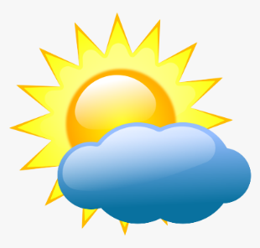
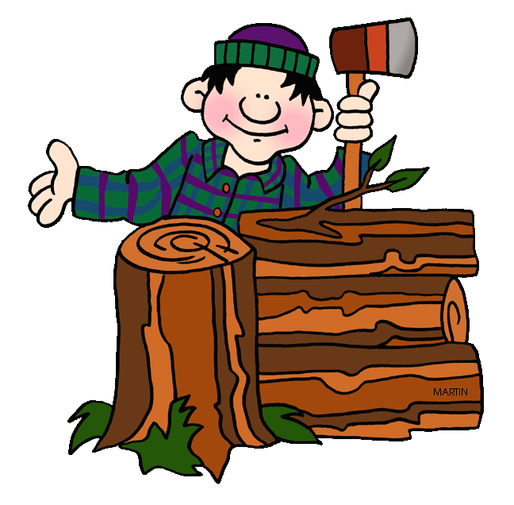
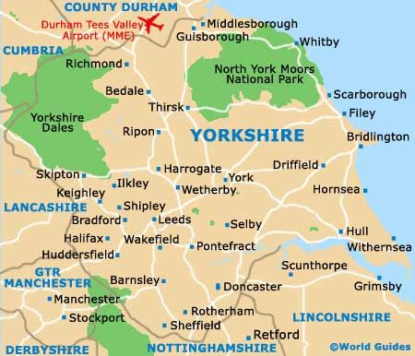

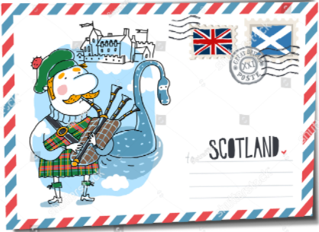
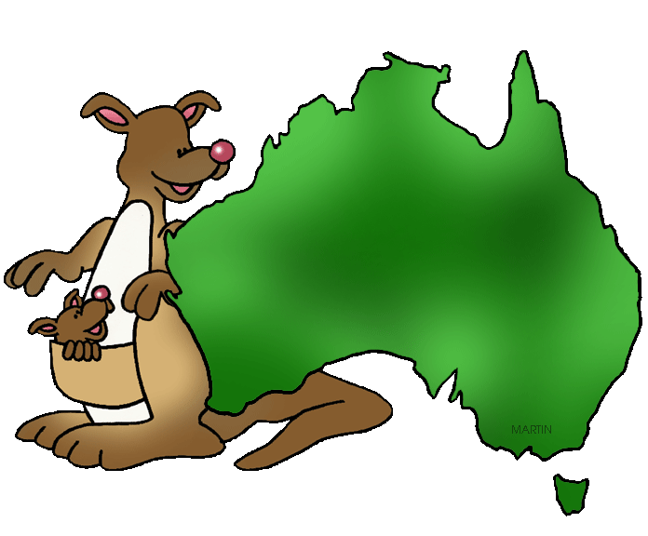

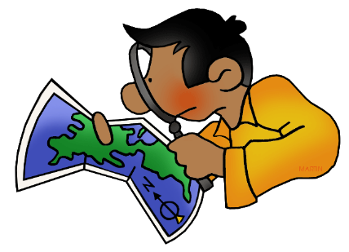
Newbald Primary School


Framework
Geography

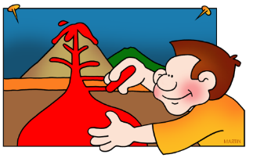
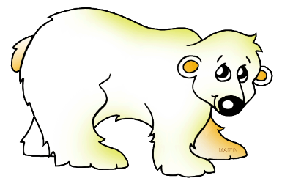

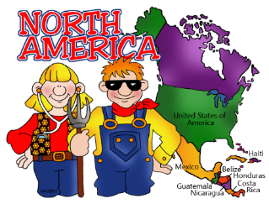
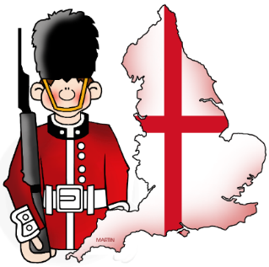

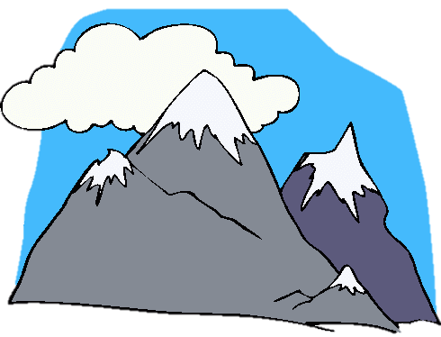
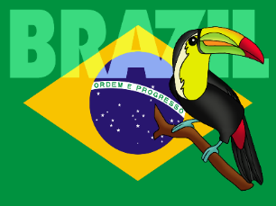


Geography at Newbald Primary School

Our curriculum is designed to be cross curricular through topic related links (usually history and geography). Other subjects such as art, computing, design and technology and English give a greater opportunity to ensure deeper learning opportunities for children to widen their understanding of geography.
English has been strategically chosen to be linked with the class history /geography topic to widen the amount of learning opportunities to learn, acquire, embed and apply knowledge.
Topic lessons give the opportunity for application of geographical knowledge and skills to be applied through other contexts for example historical topical links (and vice-versa). For example, whilst learning about a predominately geographical topic of ‘The Polar Regions’ children will be given the chance to lean about historical event of the race to the poles between Amundsen and Scott. As part of historical topics such as World War 1 children will be given geographical opportunities such as looking at historical maps to see how countries and their borders have changed through time.
History specific objectives as outlined in the national curriculum are taught across a 2-year cycle and are covered through links to specific topics as outlined on the following pages. History topics are highlighted.
Vocabulary
Children should use a wide vocabulary of geographical terms. Examples of expected vocabulary & terms are outlined in our school progression of vocabulary document.
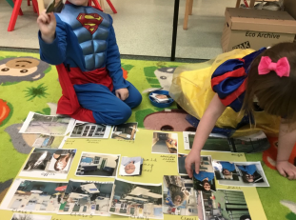
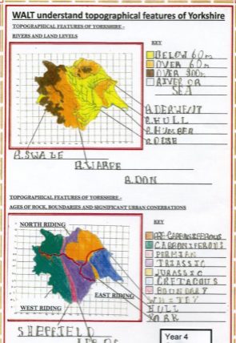

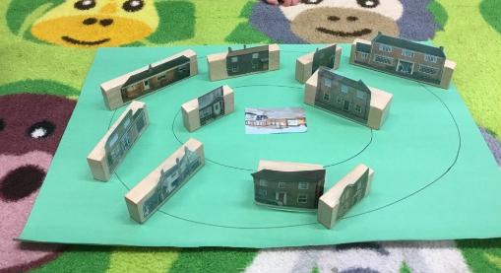
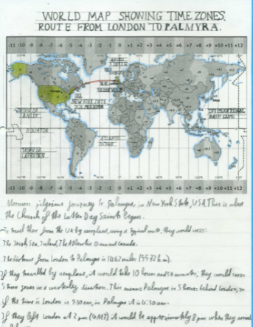

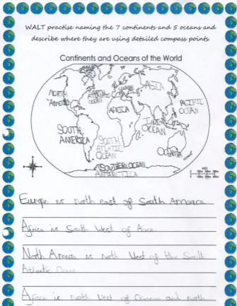

Core Concepts
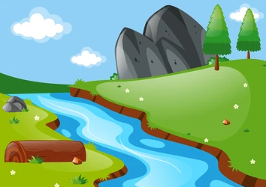
Within the subject of geography each topic/unit of study is designed to cover the core concepts of geography outlined below:
Locational Knowledge
Each year, the children at Newbald Primary school learn about a specific country from a different continent around the world (including Antarctica) learning about their environmental regions, key physical and human characteristics, countries, and major cities. Over time the children will study all 7 continents and identify similarities and differences. Children will be familiar with identifying all 7 continents and the five oceans of the world. Children will develop knowledge and skills.
Each double year group phase has a topic specifically designed to target learning about the United Kingdom. These topics will enable the children to locate and identify counties and cities of the United Kingdom and surrounding seas, geographical regions and their identifying human and physical characteristics, key topographical features (including hills, mountains, coasts and rivers), and land-use patterns; and understand how some of these aspects have changed over time.
Both studies of countries and continents along with studies of the United Kingdom, will give the children opportunities to identify the position and significance of latitude, longitude, Equator, Northern Hemisphere, Southern Hemisphere, the Tropics of Cancer and Capricorn, Arctic and Antarctic Circle, the Prime/Greenwich Meridian and time zones (including day and night).

Place Knowledge
Children are given opportunities through their geographical topics to study a small area within a country. An example of this is studying Colorado as part of the Year 3&4 topic of the USA and North America. The children have created a link with a school in Colorado and write letters to find out more about the place. Children are given opportunities to understand geographical similarities and differences through studying the human and physical geography of a small areas and regions in contrasting countries from around the world. The children compare this with their own locality (Newbald) and other small areas of the United Kingdom they have learnt about.

Human & Physical Geography Knowledge
Children will be given opportunities to develop their human and physical geographical knowledge. Children will study human geography, the interrelationships between people, place, and environment, and how these vary spatially and temporally across and between locations. They will also learn about physical geography concentrating on spatial and environmental processes that shape the natural world, drawing on the natural and physical sciences for its scientific underpinnings and methods of investigation.
Topics such as weather and climate, the polar regions, and studies of the United Kingdom and country / continent studies around the world regions of Scotland in Key Stage 1 gives the children ideal opportunity to identify seasonal and daily weather patterns in the United Kingdom and the location of hot and cold areas of the world in relation to the Equator and the North and South Poles
It is imperative that the children use appropriate geographical vocabulary to refer to:
- key physical features, including: beach, cliff, coast, forest, hill, mountain, sea, ocean, river, soil, valley, vegetation, season and weather
- physical geography, including: climate zones, biomes and vegetation belts, rivers, mountains, volcanoes and earthquakes, and the water cycle
- key human features, including: city, town, village, factory, farm, house, office, port, harbour and shop
- human geography, including: types of settlement and land use, economic activity including trade links, and the distribution of natural resources including energy, food, minerals and water
Geographical Skills & Fieldwork Knowledge
Our progression ensures that children use maps throughout their learning journey from simplistic maps of their locality to more detailed OS maps. Children use world maps, atlases and globes digital/computer mapping to identify the United Kingdom and its countries, as well as the countries, continents and oceans studied. They use aerial photographs and plan perspectives to recognise landmarks and basic human and physical features. They devise a simple maps and build and use map symbols in a key.
Children are encouraged to use appropriate geographical vocabulary and use compass directions building to using the eight points of a compass. Children will use coordinates and build knowledge to use four and six-figure grid references, symbols and key (including the use of Ordnance Survey maps) to build their knowledge of the United Kingdom and the wider world
Children are encouraged to experience fieldwork and observational skills first hand. As part of local area studies, children study the geography of their school and its grounds identifying the key human and physical features of its surrounding environment. Children experience first-hand fieldwork when learning about topics such as coasts, where they visit Bempton Cliffs to observe and learn about the human and physical geography. Trips and visits linked to geographical topics are encouraged and trips such as local area visits, visits to the beach, Yorkshire Wildlife Park, The Deep, Dalby Forest, Bempton Cliffs enrich the children’s learning.

Newbald Primary School Topic Links Cycle 1
Geography specific topics are highlighted in green
 | Hedgehog  Class | Squirrel  Class | Fox  Class | Otter  Class
Autumn 1 | People who help us  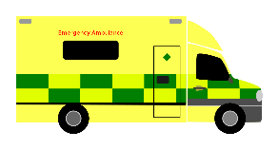 | Nurses including Florence Nightingale & Mary Seacole  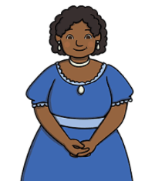 | 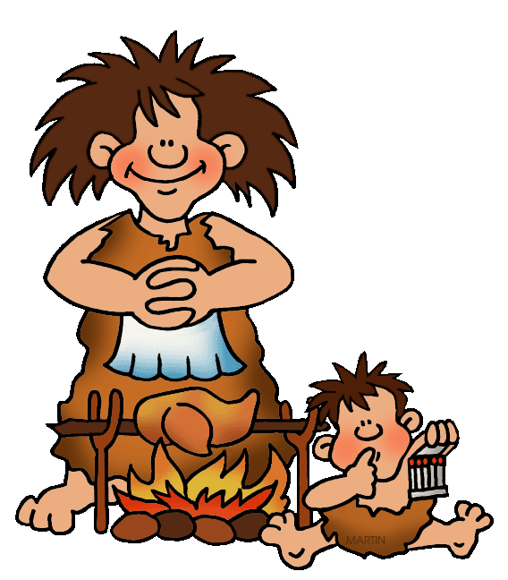  Prehistoric Britain | 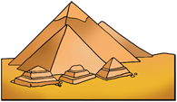  Ancient Egypt
Autumn 2 | 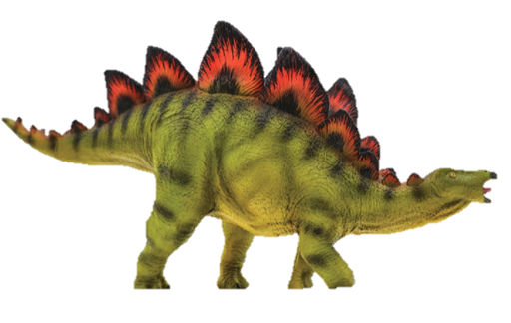  Dinosaurs |   Australia & Oceania | 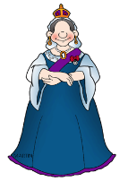  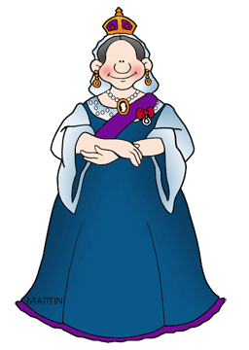  The Victorians | 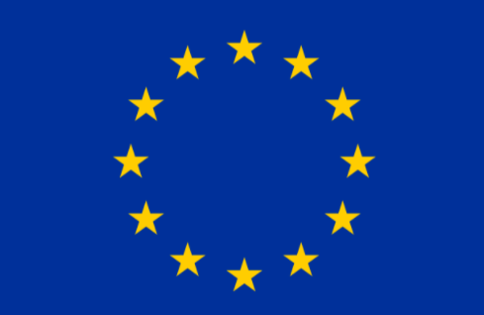  Europe
Spring 1 | The World & Africa  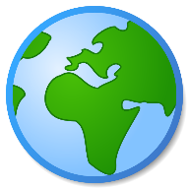 | Weather & Climate   | 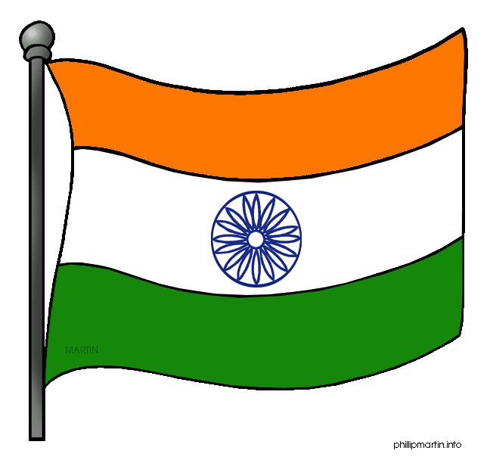  India & Asia | 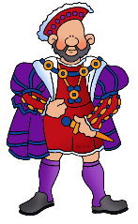  The Tudors
Spring 2 | Traditional Tales  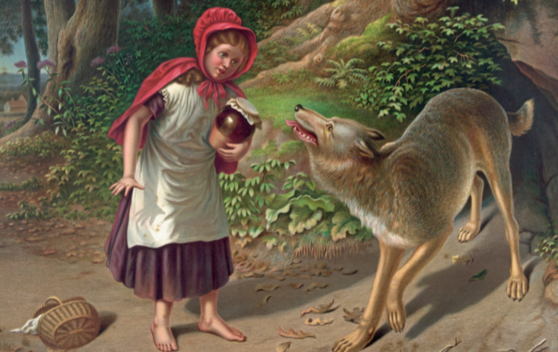 | 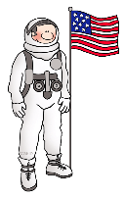  Explorers | England & The United Kingdom  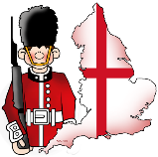 | 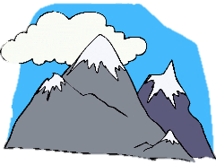  Mountains
Summer 1 | Growing  (Eric Carle / Life-cycles)  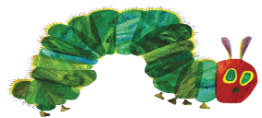 | 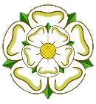  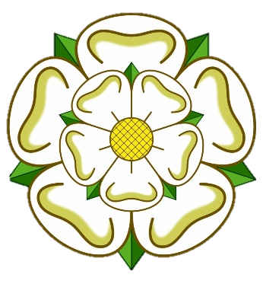  Our Local Area: Yorkshire | Coasts  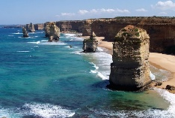 | Britain Since 1945  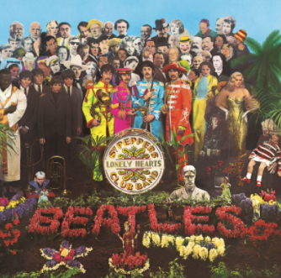
Summer 2 | Houses & Homes  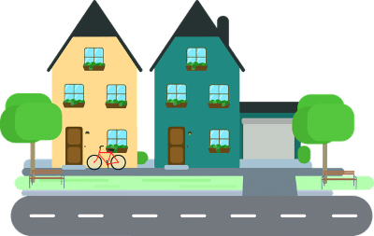 |   Inventors & Inventions | 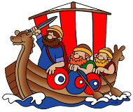  The Anglo Saxons & Vikings  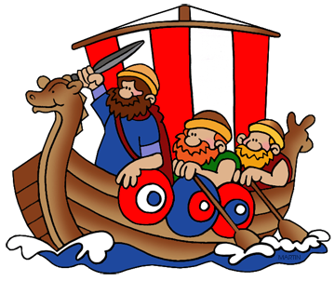 | 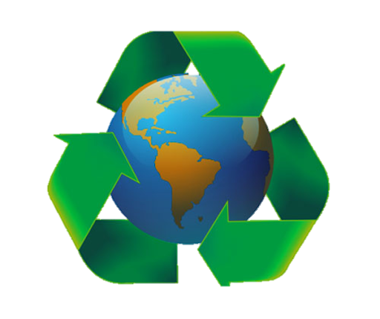  Environmental Studies, Wildlife and Ecosystems

Newbald Primary School Topic Lincs Cycle 2
Geography specific topics are highlighted in green
 | Hedgehog  Class | Squirrel  Class | Fox  Class | Otter  Class
Autumn 1 | All About Me  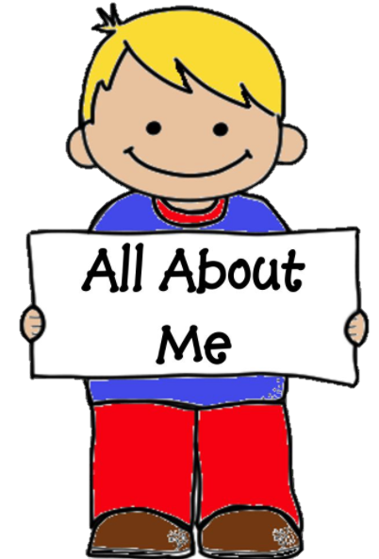 | Transport Through Time  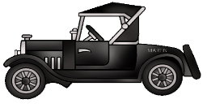 | World War 2 | World War 1  
Autumn 2 | 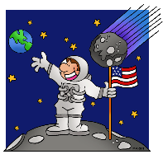  Space | The Polar Regions  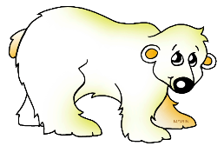 | U.S.A & North America   | Brazil & South America  
Spring 1 | Newbald  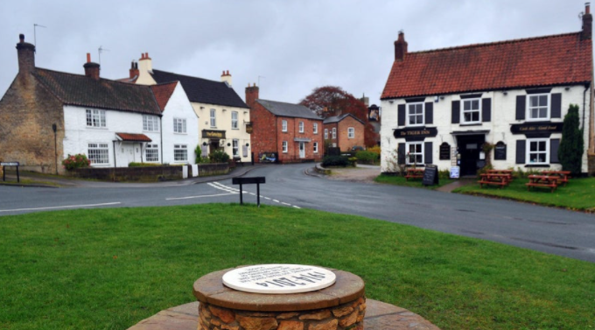 | The Great Fire of London  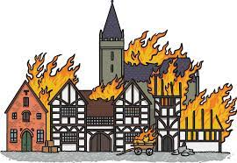 | The Romans  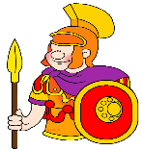 | Ancient Greece  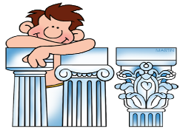
Spring 2 | Julia Donaldson  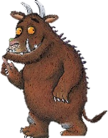 | Pirates & the Oceans  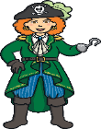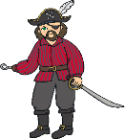 | Volcanoes, Earthquakes & Natural Disasters  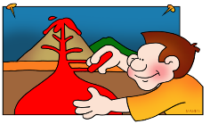 | Human Rights Activists  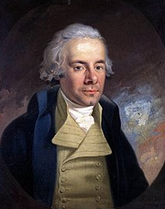
Summer 1 | Minibeasts  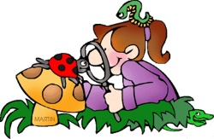 | An Island Home (Scotland)  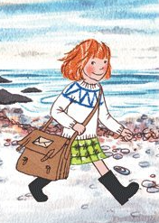 | Forests | The Mayan Civilisation  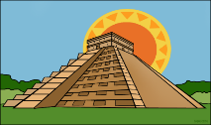
Summer 2 | Beside the Seaside  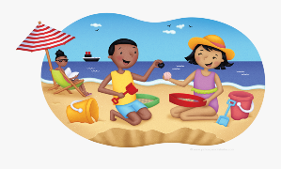 | Kings & Queens  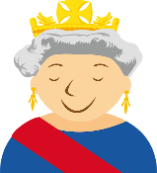 | Middle Ages  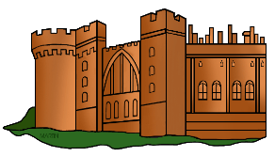 | Maps & Rivers  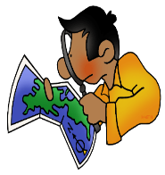


Level expected at the end of EYFS
Progression of Knowledge and Skills

We have selected the Early Learning Goals that link most closely to the Geography National Curriculum.
Understanding the World (The World)
Children know about similarities and differences in relation to places, objects, materials and living things. They talk about the features of their own immediate environment and how environments might vary from one another.
Understanding the World (People and Communities)
Children know about similarities and differences between themselves and others, and among families, communities and traditions.

Key Stage 1 National Curriculum Expectations
Locational Knowledge  Pupils should be taught to:  - name and locate the world’s seven continents and five oceans;  - name, locate and identify characteristics of the four countries and capital cities of the United Kingdom and its surrounding seas.  Place Knowledge  Pupils should be taught to:  - understand geographical similarities and differences through studying the human and physical geography of a small area of the United Kingdom, and of a small area in a contrasting non-European country.  Human and Physical Geography  Pupils should be taught to:  - identify seasonal and daily weather patterns in the United Kingdom and the location of hot and cold areas of the world in relation to the Equator and the North and South Poles;  - use basic geographical vocabulary to refer to:  -key physical features, including: beach, cliff, coast, forest, hill, mountain, sea, ocean,  river, soil, valley, vegetation, season and weather;  -key human features, including: city, town, village, factory, farm, house, office, port,  harbour and shop. | Geographical Skills and Fieldwork  Pupils should be taught to:  - use world maps, atlases and globes to identify the United Kingdom and its countries, as well as the countries, continents and oceans studied at this key stage;  - use simple compass directions (North, South, East and West) and locational and directional language [for example, near and far; left and right], to describe the location of features and routes on a map;  - use aerial photographs and plan perspectives to recognise landmarks and basic human and physical features; devise a simple map; and use and construct basic symbols in a key;  - use simple fieldwork and observational skills to study the geography of their school and its grounds and the key human and physical features of its surrounding environment.

Key Stage 2 National Curriculum Expectations
Locational Knowledge  Pupils should be taught to:  - locate the world’s countries, using maps to focus on Europe (including the location of Russia) and North and South America, concentrating on their environmental regions, key physical and human characteristics, countries, and major cities;  - name and locate counties and cities of the United Kingdom, geographical regions and their identifying human and physical characteristics, key topographical features (including hills, mountains, coasts and rivers), and land-use patterns; and understand how some of these aspects have changed over time;  - identify the position and significance of latitude, longitude, Equator, Northern Hemisphere, Southern Hemisphere, the Tropics of Cancer and Capricorn, Arctic and Antarctic Circle, the Prime/Greenwich Meridian and time zones (including day and night).  Place Knowledge  Pupils should be taught to:  - understand geographical similarities and differences through the study of human and physical geography of a region of the United Kingdom, a region in a European country, and a region within North or South America. | Human and Physical Geography  Pupils should be taught to:  - describe and understand key aspects of:  - physical geography, including: climate zones, biomes and vegetation belts, rivers,  mountains, volcanoes and earthquakes, and the water cycle;  - human geography, including: types of settlement and land use, economic activity  including trade links, and the distribution of natural resources including energy, food,  minerals and water.  Geographical Skills and Fieldwork  Pupils should be taught to:  - use maps, atlases, globes and digital/computer mapping to locate countries and describe features studied;  - use the eight points of a compass, four and six-figure grid references, symbols and key (including the use of Ordnance Survey maps) to build their knowledge of the United Kingdom and the wider world;  - use fieldwork to observe, measure, record and present the human and physical features in the local area using a range of methods, including sketch maps, plans and graphs, and digital technologies.

Intent
Our curriculum design enables children build a broad and deep understanding of the four areas of geography identified in the curriculum. Our carefully designed units of study build upon previous learning to ensure accelerated progression of geographical knowledge and skills. It will enable children to develop contextual knowledge of their own location, the United Kingdom and the wider world. Children will learn about all 7 continent, 5 oceans and the location of globally significant places, understanding the processes that give rise to key physical and human geographical features of the world, along with how they bring about variation and change over time. We intend to develop children’s curiosity and a fascination of the world and its people that will remain with them for the rest of their lives. Our topics/ units of study offer a range of opportunities for investigating places around the world as well as physical and human processes. The lessons are intended to improve children’s geographical vocabulary, map skills and geographical facts and provide opportunities for consolidation, challenge and variety to ensure interest and progress in the subject. Geography learning continues beyond subject specific lessons and our topics enable a variety of learning opportunities across the curriculum.

Implementation
In KS1, children begin to use maps and recognise physical and human features to do with the local area, using maps to explore the continents and oceans of the world. Children will begin to compare where they live to places outside of Europe (such as Australasia & the Polar Regions) and ask and answer geographical questions. In KS2, map skills are developed further using digital maps, more keys and symbols and children begin to use more fieldwork skills, which they will experience first hand through trips to places such as Bempton Cliffs to learn about coastal features. Through revisiting and consolidating skills, our carefully planned units of study and resources help children build on prior knowledge alongside introducing new skills and challenge. All children expand on their skills in local knowledge, place knowledge, human and physical geography, geographical skills and fieldwork. Across both key stages, children have a range of opportunities to experience geography through practical engaging tasks beyond the classroom.

Impact
Geography is at the heart of our curriculum and is evident in its cross curricular links. Children enjoy learning about the wider world and geographical concepts. As a result of following our carefully sequences units of study, teachers have higher expectations and more quality evidence can be presented in books. All children will use geographical vocabulary accurately and understand the different strands of geography, with a deep understanding of the Earth’s key physical and human processes. Children will begin to make relevant links from geography to other curriculum subjects, such as history and science. They will improve their enquiry skills and inquisitiveness about the world around them, and their impact on the world. All children will realise that they have choices to make in the world, developing a positive commitment to the environment and the future of the planet. Children will become competent in collecting, analysing and communicating a range of data gathered. They will be able to interpret a range of sources of geographical information and they will communicate geographical information in a variety of ways. All children in the school will be able to speak confidently about their geography learning, skills and knowledge.
Impact
We believe that the impact of using PlanIt Geography lessons as the basis of your curriculum is that geography learning is loved by teachers and pupils across school, teachers have higher expectations and more quality evidence can be presented in books. All children will use geographical vocabulary accurately and understand the different strands of geography, with a deep understanding of the Earth’s key physical and human processes. Children will begin to make relevant links from geography to other curriculum subjects, such as history and science. They will improve their enquiry skills and inquisitiveness about the world around them, and their impact on the world. All children will realise that they have choices to make in the world, developing a positive commitment to the environment and the future of the planet. Children will become competent in collecting, analysing and communicating a range of data gathered. They will be able to interpret a range of sources of geographical information and they will communicate geographical information in a variety of ways. All children in the school will be able to speak confidently about their geography learning, skills and knowledge.

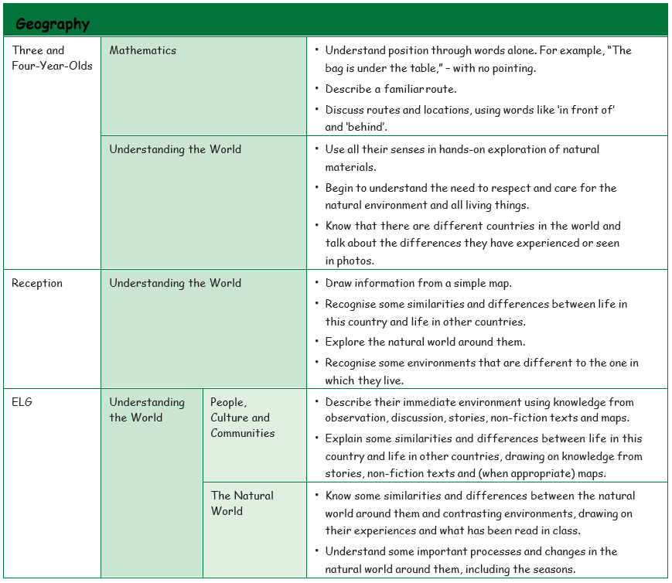
Geography in EYFS
The EYFS framework is structured differently to the national curriculum as it is organised across seven areas of learning rather than subject areas.
This table demonstrates which statements from the 2020 Development Matters are prerequisite skills for geography within the national curriculum. The table to the right outlines the most relevant statements taken from the Early Learning Goals in the EYFS statutory framework and the Development Matters age ranges for Three and Four-Year-Olds and Reception to match the programme of study for geography.
The most relevant statements for geography are taken from the following areas of learning:
- Mathematics
- Understanding the World

 | Year 1 & 2  Progression of Knowledge and Skills | Year 3 & 4 | Year 5 & 6
Locational Knowledge | Building on EYFS knowledge of their own environment, children start to learn the names of key places in the UK beyond their immediate environment. Children also learn the names of the world’s oceans and continents. Children begin to explore the Polar Regions and Australasia using maps to find these locations.  KS1 Geography National Curriculum  Pupils develop contextual knowledge of the location of globally significant places. They should develop knowledge about the world, the United Kingdom and their locality.  Children can:  - name and locate the world’s seven continents and five oceans;  - name, locate and identify characteristics of the four countries and capital cities of the United Kingdom and its surrounding seas;  - use key vocabulary to demonstrate knowledge and understanding in this strand: United Kingdom, England, Scotland, Wales, Northern Ireland, town, city, village, sea, beach, hill, mountain, London, Belfast, Cardiff, Edinburgh, capital city, world map, continent, ocean, Europe, Africa, Asia, Australasia, North America, South America, Antarctica. | Building on KS1 knowledge of the UK, children begin to explore more of the world, understand how the world has zones and the significance of those zones. Locating places and features accurately on maps also becomes a focus. Children begin to explore North America and Asia using maps to find these locations.  KS2 Geography National Curriculum  Pupils should extend their knowledge and understanding beyond the local area to include the United Kingdom and Europe, North America and Asia.  Children can develop contextual knowledge of the location of globally significant places – both terrestrial and marine.  Children develop their understanding, recognising and identifying key physical and human geographical features.  Children can:  - locate the world’s countries, using maps to focus on South America, concentrating on environmental regions and key physical and human characteristics;  - name and locate counties and cities of the United Kingdom, identifying human and physical characteristics including hills, mountains, rivers and seas, and how a place has changed;  - identify the position and significance of latitude, longitude, Equator, Northern Hemisphere, Southern Hemisphere, the Tropics of Cancer and Capricorn, Arctic and Antarctic Circle, the Prime/Greenwich Meridian and time zones;  - use key vocabulary to demonstrate knowledge and understanding in this strand: county, country, town, coast, physical features, human features, mountain, hill, river, sea, climate, tropics, tropical, of latitude, longitude, Equator, Northern Hemisphere, Southern Hemisphere, the Tropics of Cancer and Capricorn, Arctic and Antarctic Circle. | Children begin to explore Europe and South America using maps to find these locations. Children use their knowledge of longitude, latitude, coordinates and indexes to locate places. Compared to Lower KS2, children focus more on finding locations outside of the UK.  KS2 Geography National Curriculum  Pupils should extend their knowledge and understanding beyond the local area to include the United Kingdom and Europe (including Russia) and South America. They will begin to explore the concept of tourism and its impact. Children can develop contextual knowledge of the location of globally significant places – both terrestrial and marine.  Children develop their understanding of recognising and identifying key physical and human geographical features of the world; how these are interdependent and how they bring about spatial variation and change over time.  Children can:  - use maps to locate the world’s countries with a focus on Europe (Including Eastern Europe) and South America, concentrating on their environmental regions, key physical and human characteristics, countries, and major cities;  - name and locate counties and cities of the United Kingdom, identifying their physical features, including mountains, and rivers, and land-use patterns; showing change over time;  - identify the position and significance of latitude, longitude, Equator, Northern Hemisphere, Southern Hemisphere and use longitude and latitude to find locations on a map;  - use key vocabulary to demonstrate knowledge and understanding in this strand: atlas, index, coordinates, latitude, longitude, contour, altitude, peaks, slopes, continent, country, city, South America, border, key.
Place Knowledge | Children begin to compare places in the UK with a place outside of the UK. This builds on EYFS knowledge and understanding of the world, people and communities. Children can apply the skills of observing similarities and differences to places as well as people.  KS1 Geography National Curriculum  Pupils develop contextual knowledge of the location of globally significant places. They should develop knowledge about the world, the United Kingdom and their locality. Children begin to understand basic vocabulary relating to human and physical geography.  Children can:  - compare the UK with a contrasting country in the world;  - compare a local city/town in the UK with a contrasting city/town in a different country;  - use key vocabulary to demonstrate knowledge and understanding in this strand: Australia, Australasia, North America, South America, Europe, Asia, Antarctica, Africa, London, Sydney, Canberra, compare, capital city, Polar Regions, Arctic, Antarctic, Canada, country, population, weather, similarities, differences, farming, culture, Kenya, Nairobi, river, desert, volcano. | Children develop vocabulary relating to physical and human geographical features from KS1. They begin to develop the skills of comparing regions, by focusing on specific features. Children focus on comparing regions of the UK in depth and start to look at an area outside of the UK.  KS2 Geography National Curriculum  Children can understand geographical similarities and differences through the study of human and physical geography of a region of the United Kingdom, a region in an Asian country and a region within North America.  Children can:  - understand geographical similarities and differences through the study of human geography of a region of the United Kingdom;  - explore similarities and differences, comparing the human geography of a region of the UK and a region of North America/ Asia;  - understand geographical similarities and differences through the study of physical geography of a region of the United Kingdom;  - explore similarities and differences comparing the physical geography of a region of the UK and a region of North America / Asia;  - use key vocabulary to demonstrate knowledge and understanding in this strand: Amazon rainforest, Sherwood Forest, York, Newbald, Yorkshire, Sheffield, Hull, city, physical features, human features, landscape, feature, population, land use, retail, leisure, housing, business, industrial, agricultural. | Children develop their analytical skills by comparing areas of the UK with areas outside of the UK. They will have a deeper knowledge of diverse places, people, resources, natural, and human environments. They can make links to places outside of the UK and where they live. Children are encouraged to conduct independent research, asking and answering questions.  KS2 Geography National Curriculum  Children can understand geographical similarities and differences through the study of human and physical geography of a region of the United Kingdom, a region in a European country, and a region within South America.  Children can:  - understand geographical similarities and differences through the study of human geography of a region of the United Kingdom, a region of Europe (including Eastern Europe) and South America;  - understand geographical similarities and differences through the study of physical geography of a region of the United Kingdom, a region of Europe (including Eastern Europe) and South America;  - use key vocabulary to demonstrate knowledge and understanding in this strand: latitude, Arctic Circle, physical features, climate, human geography, land use, settlement, economy, natural resources.

Human and Physical Geography | Building on EYFS knowledge of how environments may vary. Children begin to learn about the physical and human features of geography.  KS1 Geography National Curriculum  Children will understand key physical and human geographical features of the world. They identify seasonal and daily weather patterns.  Children can:  - identify seasonal and daily weather patterns in the United Kingdom and the location of hot and cold areas of the world in relation to the Equator and the North and South Poles;  - use basic geographical vocabulary to refer to key physical features, including: beach, cliff, coast, forest, hill, mountain, sea, ocean, river, soil, valley, vegetation, season and weather;  - use basic geographical vocabulary to refer to key human features, including: city, town, village, factory, farm, house, office, port, harbour and shop. | Children have a stronger understanding of the difference between physical and human geography. They use more precise vocabulary, explaining the processes of physical and human geography and their significance. They learn more about extreme weather, the processes involved in the causes and effects of extreme weather, as well as beginning to understand the impact of humans on the earth.  KS2 Geography National Curriculum  Children locate a range of the world’s most significant human and physical features. Explain how physical features have formed, why they are significant and how they can change.  Explain the impact of humans on the earth in terms of land use, settlements and their direct connection to physical changes.  Children can:  describe and understand key aspects of:  - physical geography, including: climate zones, biomes, volcanoes, tornadoes, tsunamis, earthquakes and the water cycle;  - human geography, including: types of settlement and land use;  - use key vocabulary to demonstrate knowledge and understanding in this strand: mantle, outer core, inner core, magma, volcano, active, dormant, extinct, earthquake, epicentre, shock wave, magnitude, tsunami, tornado, climate, tropics, deforestation, evaporation, water cycle, evaporation, condensation, precipitation, cooling, filter, pollution, settlement, settler, site, need, shelter, food. | Children deepen their understanding of the difference between physical and human geography. They can explain the terminology of both aspects of geography with a range of examples. They spend time exploring human geography and the impact humans have on the world. They focus on trade links, resources and the distribution of resources around the world. Children also learn about the different types of mountains.  KS2 Geography National Curriculum  Children will locate a range of the world’s most significant human and physical features. Explain how physical features have formed, why they are significant and how they can change. Children can understand how these are interdependent and how they bring about spatial variation and change over time. Children will deepen their understanding of the interaction between physical and human processes, and of the formation and use of landscapes and environments.  Children can:  describe and understand key aspects of:  - physical geography, including: climate zones, biomes/ ecosystems and vegetation belts, mountains and the water cycle;  - human geography, including: types of settlement and land use, economic activity including trade links, and the distribution of natural resources including energy, food, minerals and water;  - use key vocabulary to demonstrate knowledge and understanding in this strand: environmental disaster, settlement, resources, services, goods, electricity, supply, generation, renewable, non-renewable, solar power, wind power, biomass, origin, import, export, trade, efficiency, conservation, carbon footprint, peak, plateau, fold mountain, fault-block mountain, dome mountain, volcanic mountain, plateau mountain, tourism, positive, negative, economic, social, environmental.

Geographical Skills and Fieldwork | Building on EYFS knowledge of their own environment, children begin to use maps to locate places and name features using keys and symbols. Children also begin to look at how the environment has changed over time.  KS1 Geography National Curriculum  Children can interpret geographical information from a range of sources. They can communicate geographical information in a variety of ways.  Children can:  - use world maps, atlases and globes to identify the countries, continents and oceans studied at this key stage;  - use simple compass directions and locational and directional to describe the location of features and routes on a map;  - devise a simple map; and use and construct basic symbols in a key;  - use simple fieldwork and observational skills to study the geography of the surrounding area, including key human and physical features, using a range of methods;  - use key vocabulary to demonstrate knowledge and understanding in this strand: compass, 4-point, direction, North, East, South, West, plan, record, observe, aerial view, key, map, symbols, direction, position, route, journey, the UK, changes, tally chart, pictogram, world map, country, continent, human, physical. | Children begin to develop their map skills. They will be able to identify features on a map through the use of symbols and keys. Children begin to use fieldwork skills to monitor and explain patterns in human and physical features.  KS2 Geography National Curriculum  Children collect, analyse and communicate a range of data gathered through fieldwork that deepens their understanding of geographical processes. They interpret a range of sources of geographical information including maps, diagrams, globes, aerial photographs and Geographical Information Systems (GIS).  Children can:  - use maps, atlases, globes and digital/computer mapping to locate countries and describe features studied;  - use symbols and keys (including the use of Ordnance Survey maps), to build their knowledge of the United Kingdom and the wider world;  - use fieldwork to observe and present the human and physical features in the local area using sketch maps, plans and digital technologies;  - use key vocabulary to demonstrate knowledge and understanding in this strand: sketch map, map, aerial view, feature, annotation, landmark, distance, key, symbol, land use, urban, rural, population, coordinates. | Children build on their map skills by communicating locations through grid references and coordinates. They also explain what makes a good map symbol and why. Children focus on observing and recording the changes of human features over time, for example trade patterns.  KS2 Geography National Curriculum  Children will become confident in collecting, analysing, and communicating a range of data. Children can explain how the Earth’s features at different scales are shaped, interconnected and change over time.  Children can:  - use maps, atlases, globes and digital/computer mapping to locate countries and describe features;  - use the eight points of a compass, four and six-figure grid references, symbols and key (including the use of Ordnance Survey maps) to build their knowledge of the United Kingdom and the wider world;  - use fieldwork to observe, measure, record and present human features using a range of methods, including sketch maps, plans and graphs, and digital technologies;  - use key vocabulary to demonstrate knowledge and understanding in this strand: atlas, index, coordinates, latitude, longitude, key, symbol, Ordnance Survey, Silva compass, legend, borders, fieldwork, measure, observe, record, map, sketch, graph.

