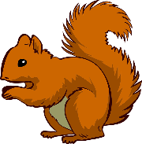
HOME LEARNING
ACTIVITIES

Activities – Monday 13th July – Friday 17th July 2020

As this is the last week of the school year, please find some different activities available to download from the school website.

Science Investigation - Dissolving

Science Investigation - Fireworks in a glass

Science Investigation - Fun with density

My Five Senses Scavenger Hunt

Science Investigation - Lava lamp

Dinosaur Wordsearch

Dinosaur paper crafts - Diplodocus, T-Rex and Stegosaurus

Dinosaur themed mindfulness colouring

