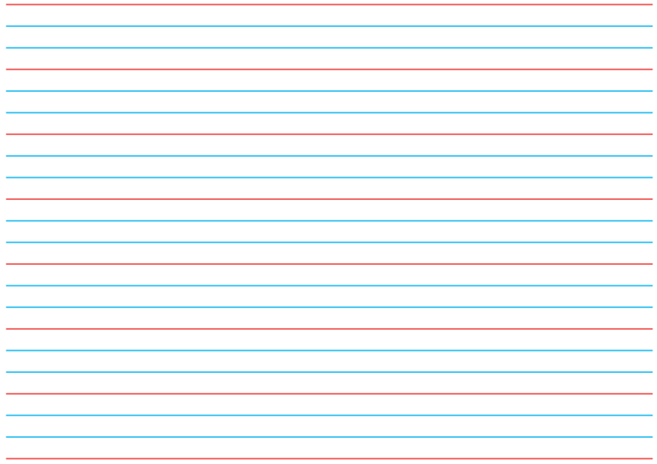
Will Cody stay a caterpillar? What does Cody turn into? What happens?
Think of words to describe how you think Cody might be feeling. Can you explain why?

Draw what you think Cody may look like as a butterfly. What colours will Cody be? What will her wings be like?

Describe the journey from caterpillar to butterfly.

I think Cody is happy at the end of the story. Do you agree and explain your answer.

