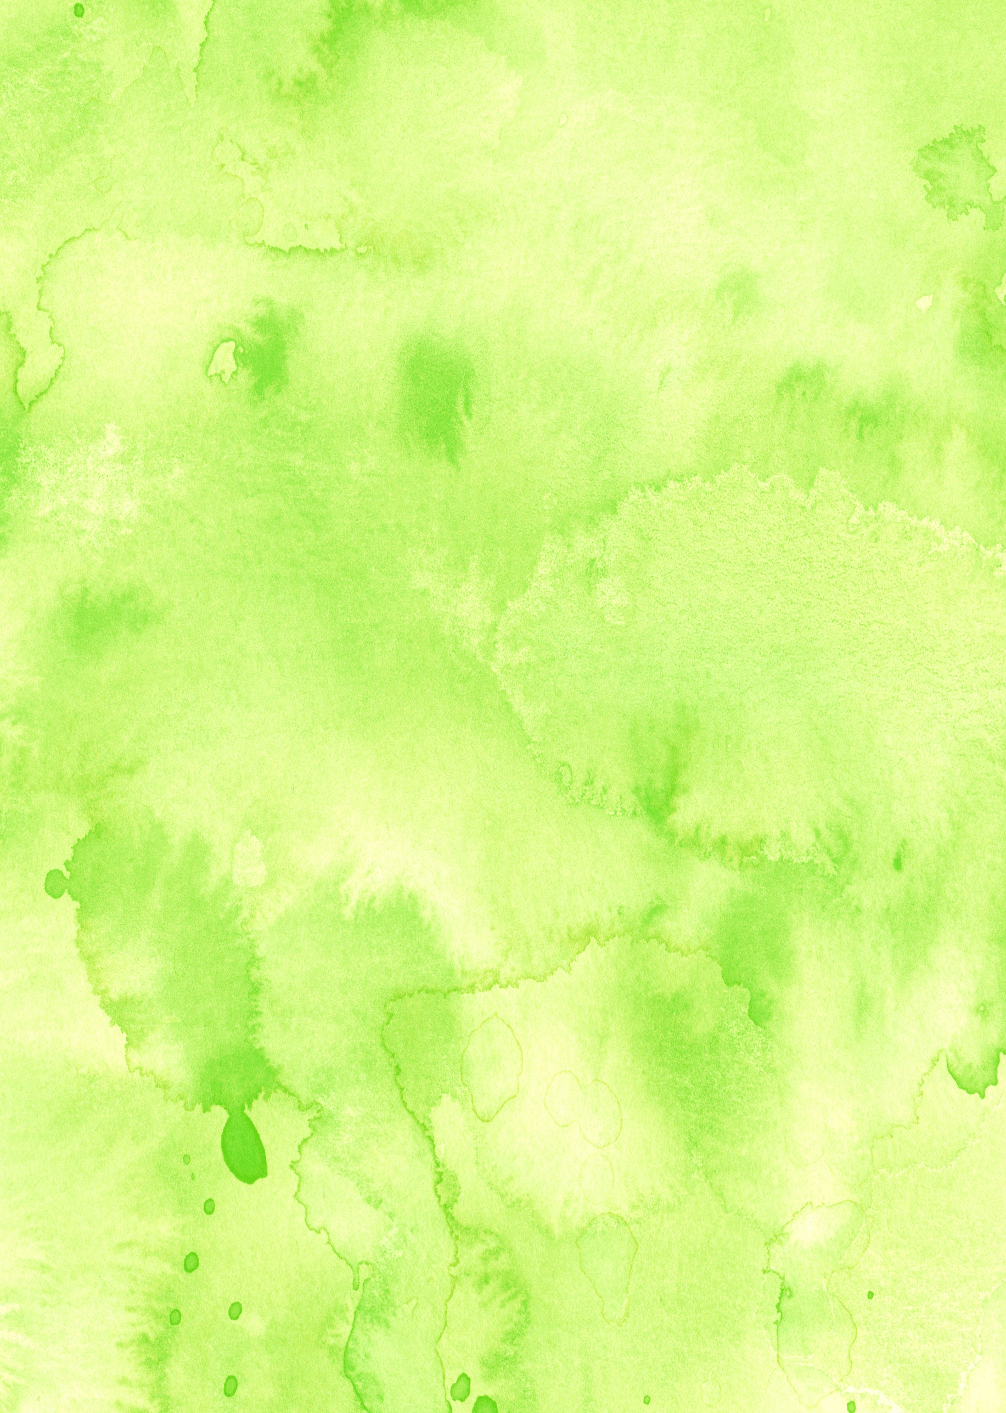



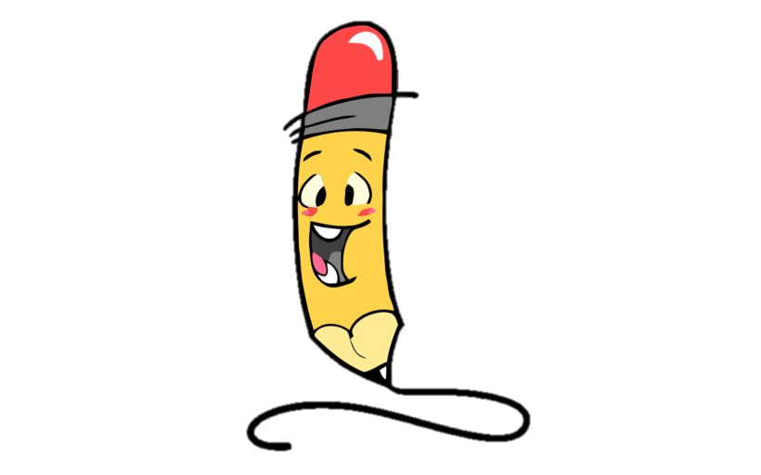
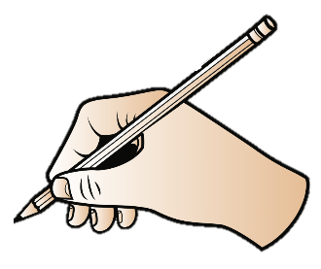
Newbald
Primary School

Handwriting &
Presentation
Guidance & Framework
for Teaching



Handwriting & Presentation at Newbald Primary School

At Newbald Primary School, handwriting is closely linked to the Read Write Inc. phonics scheme. Handwriting is taught progressively and in-line with the requirements of the National Curriculum.

Aims
We aim for our children to:
- Understand the importance of neat presentation in order to communicate their ideas clearly.
- Take pride in the presentation of their work and gain a sense of achievement.
- Present work in a neat and orderly fashion appropriate to the task.
- Use the correct letter formation.
- Develop fluency and speed whilst writing, so that they are able to write in a neat cursive style by the end of KS2.

Knowledge, skills and understanding
In the early stages children are taught:
- How to hold a pen/pencil correctly and form letters and numbers of regular size and shape.
- Write from left to write and top to bottom of a page.
- Start and finish upper and lower case letters correctly.
- Put regular spaces between letters and words.
- The importance of clear and neat presentation in order to communicate meaning effectively.

In the later stages children are taught to:
- Write legibly in a joined style with increased fluency and speed.
- Use different forms of handwriting for different purposes, e.g. understand that making quick written notes in English or jottings in maths does not require the same level of neatness as other writing or maths work.

Teachers use a variety of strategies for the teaching of handwriting including:
- Direction
- Demonstration
- Modelling
- Scaffolding
- Explanation

Basic structure of a handwriting session
- Posture check and book positioning
- Teacher modelling on the visualiser / board / flip chart
- Children practising with teacher model, then from memory

We teach letter and number formation as detailed in Appendices 1 – 3 (pages 6 – 12), using the teaching sequence described in Appendix 4 (pages 13 – 18).

In EYFS and KS1, children use a pencil in their handwriting lessons. In KS2, they will begin using a pen and will work towards a pen license, which will be at the discretion of the teacher and the headteacher. At this point, the children will begin to use blue handwriting pens. If the standard of handwriting slips, then the children will return to using pencil until they re-earn their pen license.

The use of worksheets is discouraged for the majority of children who should be able to form their handwriting by observing and copying teacher modelling.

Expectations of staff
All adults in the classroom are expected to:
- Model the school handwriting style (Appendices 1, 2 and 3) in their own handwriting.
- Teach the correct grip (see below) and ensure support is in place for children not using the correct grip
- Ensure that handwriting tasks are completed in books or on paper. Handwriting tasks should not be completed on whiteboards
- Ensure that children have a suitable pencil (or pen) and are sat at a desk / table when completing handwriting tasks
- Ensure correct formation of letters and numbers.
- Ensure correct posture with children sitting comfortably and upright, with feet flat on the floor.
- Ensure good lighting.
- Ensure each child has a suitable writing implement before they begin, pencils are adequately sharpened and pens are appropriate and suitable for fluent writing.
- Where possible link handwriting to spelling patterns.
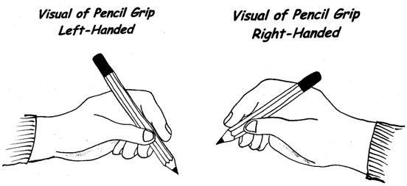

Considerations for left handed children
- Seating: sit to the left of another child, at the edge of a table.
- Grip: hold the pencil/pen at least 2cm from the point so the children can see what they are writing.
- Position of paper: to left of the body at an angle, with right hand corner nearer to the body than the left (see illustration below).
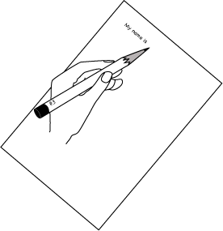

Inclusion
The vast majority of children will be able to write fluently and legibly. However, some children may need additional support to develop a fluent, legible style of handwriting. Provision will be made through additional sessions that are focused on the child’s identified specific difficulty with handwriting. Teachers who are concerned about a child’s progress in handwriting should seek advice from the SENDco.

Presentation
It is important to ensure consistency towards presentation of work across the school so that the children are clear about what is expected of them as they move through the school. The SENDco can provide pencil grips and coloured workbooks or paper to aid presentation for identified children. All staff should use the following guidelines to ensure consistency, taking into account the age and ability of the children.

7a. Writing: EYFS and KS1
- Children will write in pencil and edit in purple pen.
- All work will have a date and a title (which will be an I can statement (learning objective)). The date will be written on the left-hand side of the page. A line will be missed and the title will be written on the line beneath it. Children will be encouraged to write these themselves, though it may be necessary for an adult to do this or for some identified children. Printed titles can be used for younger children and identified children.
- The long date (e.g. Monday 1st September 2022) should be used wherever possible. The short date (e.g. 01.09.22) should be used for mathematics. A date should be written on all pieces of work.
- Children are encouraged to write from the left hand edge or margin, although the EYFS does allow more freedom when first exploring letter shapes and formation.
- A mistake should be crossed out with one line through it. This should be done neatly. A scribble is never acceptable.
- Diagrams should be drawn in pencil, unless indicated otherwise by the teacher, and should be clearly labelled.

7b. Writing: KS2
- Joined handwriting is taught from Y1 and must be actively encouraged in all pieces of written work in KS2.
- Children should write from the left-hand margin.
- All work will have a date written next to the margin. This should be underlined using a ruler from Y3. The long date (e.g. 1st September 2022) should be used wherever possible. The short date (e.g. 01.09.22) should be written in mathematics. A line will be missed and the title will be written on the line beneath it. Children should write these themselves. The title / I can - learning objective should be written on the line beneath the date and should also be underlined using a ruler.
- A mistake should be crossed out with one line through it. This should be done neatly. A scribble is never acceptable.
- Children will leave a single empty line between each paragraph.
- From Year 3, children will receive a pen licence, permitting them to use a handwriting pen, when they are able to demonstrate that they can consistently write in a fluent, joined, legible style across all of their work.
- As soon as a child has earnt a pen licence, children should be encouraged to write using blue handwriting pens and edit using purple pen. Children working towards a pen licence will write in pencil and edit in purple pen.
- Diagrams should be drawn in pencil, unless indicated otherwise by the teacher, and should be clearly labelled.

7c. Mathematics
- Suitable and sharp pencils should be used in maths, and purple pens used for self-marking, corrections and response tasks.
- All work will have the short date. A line will be missed and the title/ I can - learning objective will be written on the line beneath the date. Both will be underlined using a ruler. If printed labels or stickers are used in key stage 1, these will be stuck to the left of the page.
- Correct formation of numerals should be expected at all times (Appendix 3).
- All numbers should be written neatly and clearly and when carrying out formal maths calculations
e.g. when adding numbers with decimals, each digit should be written in a separate square.
- Each calculation should be clearly numbered (with a number and a dot) as in the example below. Where a margin is used, the number of the calculation will be written in the margin.

1. 20 + 20 = 40

2. 23 + 20 + 43

- Calculations should be clearly and appropriately spaced on the page. The page may be divided into two columns if appropriate.
- When drawing geometric shapes and graphs, charts or tables, lines must be drawn accurately using a ruler.
- Mistakes should be corrected with one neat line, e. g. 2+2=5. Ascribble is never acceptable.
- Sheets should not overhang the page and should be neatly stuck in.
- Visualisations and jottings aid thinking and therefore a ruler is not necessary; however, neat and clear layout should always be expected.
- When children are answering questions in their books, their working out must also be in their books rather than on a whiteboard/scrap paper.

Homework
Children are expected to take the same standard of care with homework as they do with the work they produce in school. Parents are encouraged to support their children to produce quality work by following the guidance set out above.

Assessment
Teachers assess handwriting and presentation as part of their routine marking in line with the marking policy. The quality of handwriting is assessed as part of the overall quality of writing as explained in the English section of the National Curriculum. Teachers will also assess if children are using the correct pencil grip and it is the teachers responsibility to notify the SENDco and to ensure that any child not using the correct pencil grip has the required intervention such as pencil grips, handwriting intervention etc.

Monitoring
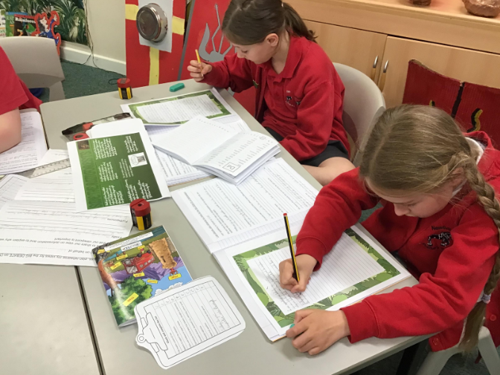
The Headteacher, SEND Co, subject leaders and class teachers will monitor handwriting and presentation through work scrutiny during the year to ensure the policy is being implemented consistently. Inconsistencies will be brought to the teacher’s attention and any inaccuracies must be dealt with within an agreed timeframe. Follow-up monitoring will take place.

Appendix 1: letter formation
We teach the Read Write Inc letter formation. There are four types of letters: ‘around’, ‘down’, curly’ and ‘zigzag’.

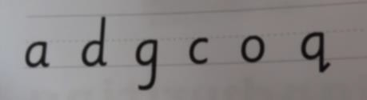
‘Around’ letters:

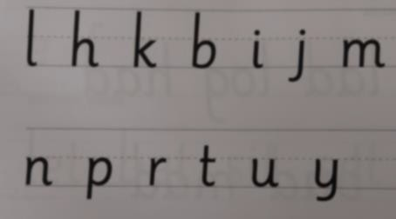
‘Down’ letters:

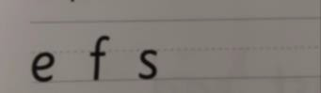
‘Curly’ letters:

‘Zigzag’ letters: 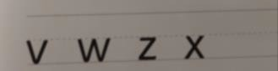

Letter formation should be taught as detailed in the checklists on pages 7 – 10 of this policy.

See also the following which are available on the school network: T:\Handwriting and Presentation 2020:
- RWI letter formation sheets a – z
- ‘Handwriting Stage 1a: Letter Formation’
- ‘Handwriting Stage 1b: Relative Size of Letters’
- ‘Handwriting Stage 2’
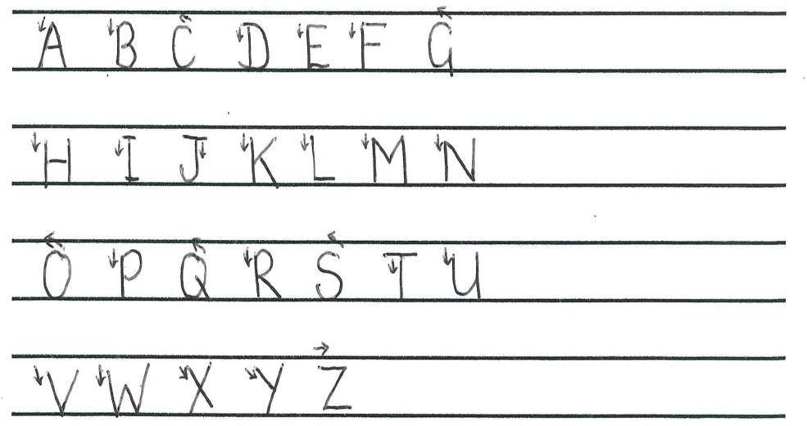
Upper case letters are formed as follows:

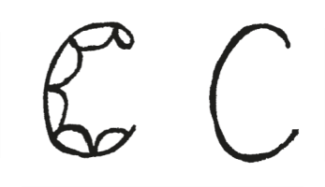
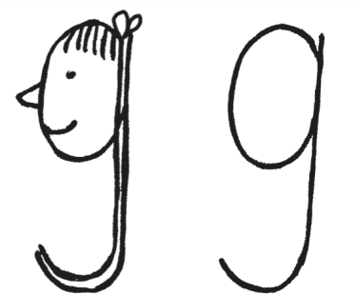
‘Around’ letters
Checklist: caterpillar
- start at the caterpillar’s head
- curl around the body

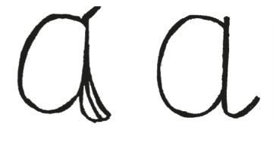
Checklist: apple
- start at the stalk
- draw a nice round apple
- go back up to the stalk, then down
- curl the leaf at the bottom

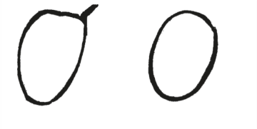
Checklist: orange
- start at the stalk
- draw a nice round orange

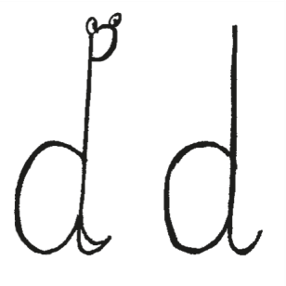

Checklist: dinosaur
- draw a big round bottom
- up the tall neck
- down the straight line to the feet
- draw a curl for the feet
Checklist: girl
- start at her hair bobble on top of her head
- draw a nice round face
- go back up to her bobble
- down her very straight hair
- draw a round curl to finish

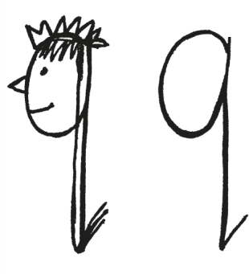

Checklist: queen
- start at her hair bobble on top of her head
- draw a nice round face
- go back up to her bobble
- down her very straight hair
- add a sharp flick to finish

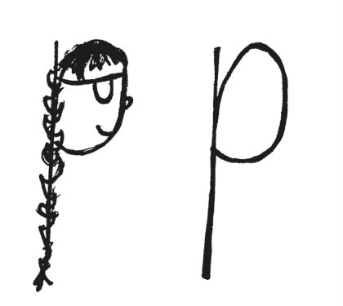
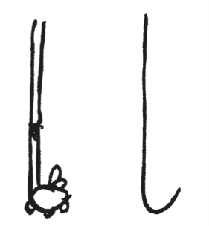
‘Down’ letters

Checklist: Liam’s leg
  - start at the top of his leg
  - go down his long leg
  - add a curl for the shoe to kick the ball
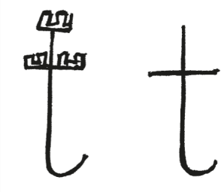
Checklist: tower
  - start at the top of the tower
  - draw a straight line down the tower
  - add a curl at the bottom – then lift the pencil off the page
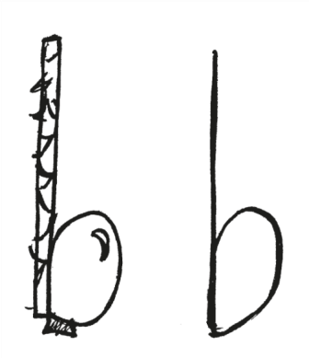
  - draw a straight line across the tower
Checklist: boot
  - start at the top of the boot
  - draw a straight line down the boot
  - go round over the toe ✓ go back to the heel

Checklist: Polly Pirate
  - start at the top of her plait
  - draw down her long straight plait
  - go round over her face
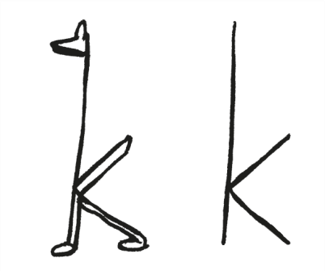
  - finish under her chin
Checklist: kangaroo
  - start at the kangaroo's head
  - draw down the long straight body – then lift the pencil off the page
  - draw a straight tail to the body – two-thirds of the way down
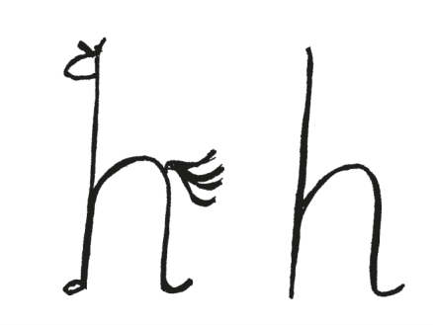
  - draw a straight back leg from the body
Checklist: horse
  - start at the horse's head
  - draw down her long straight neck
  - continue down to her feet
  - go round her back
  - draw a straight back leg
  - add a little curl of dust as the horse runs away

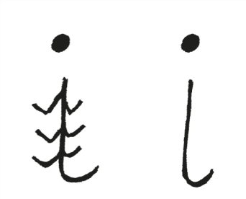
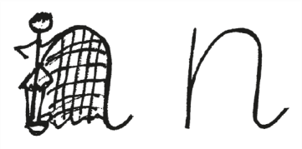

Checklist: insect
  - start at the top of the insect's neck
  - draw down the short straight body
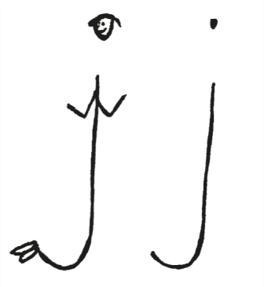
  - draw a curl for a small round tail ✓ add a little dot for the head
Checklist: jack-in-a-box
  - start at the top of the jack-in-a-box's neck
  - draw down the long straight body
  - draw a smooth curl for the legs
  - add a dot for the head
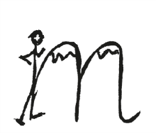
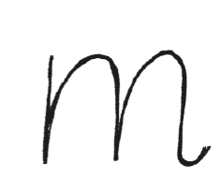
Checklist: Maisie and the mountains
  - start at Maisie's head
  - draw a straight body for Maisie
  - go over the mountains – from Maisie’s waist
  - check the mountains are the same height as Maisie
  - add a small curl for the grass
Checklist: Nobby and his net
  - start at Nobby's head
  - go straight down Nobby
  - go over the net – from Nobby’s waist
  - check the net is the same height as Nobby
  - add a small curl for the grass
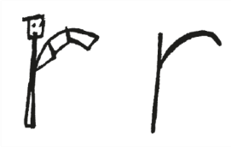
Checklist: robot
  - start at the robot's head
  - go straight down its body
  - go over the robot’s arm – from its waist
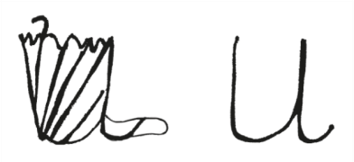
Checklist: umbrella
  - start at the top of the handle
  - draw down the straight line for the handle
  - go round underneath the umbrella and back up the other side
  - go down the umbrella
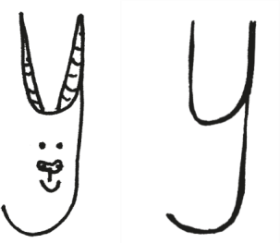
  - add a little curl for the puddle
Checklist: yak
  - start at the top of the first horn
  - draw down the straight line for the first horn
  - go round underneath the horns
  - draw a straight line up for the second horn
  - go down and curl under its head

‘Curly’ letters
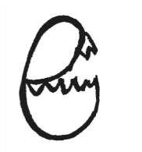
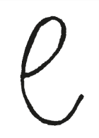
Checklist: egg
  - draw up around the shell that needs to be cut off the boiled egg
  - go round underneath the egg

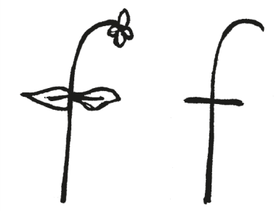
Checklist: flower
  - start at the top of the flower
  - draw around and down the flower stem – then lift the pencil off the page
  - draw a straight line across the leaves

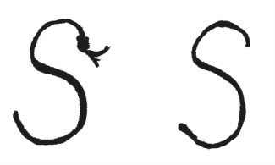
Checklist: snake
  - start at the snake's head
  - curl one way
  - curl the other

Zigzag’ letters
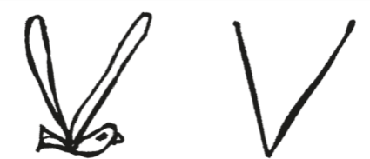
Checklist: vulture
  - draw two straight lines for the wings – down, up

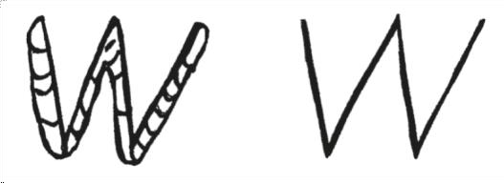
Checklist: worm
  - draw four straight lines, all the same length – down, up, down, up

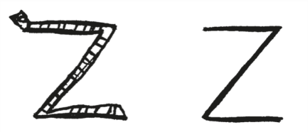
Checklist: zigzag
  - draw three straight lines – across, diagonally back, across

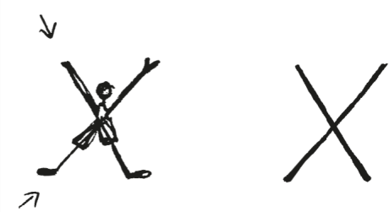
Checklist: exercise
  - start at the top left
  - draw one straight line diagonally down – lift the pencil off the page
  - start at the bottom left
  - go diagonally up

Appendix 2: joining letters

We teach the Read Write Inc letter joins. There are two basic joins:
    - the arm join (diagonal)
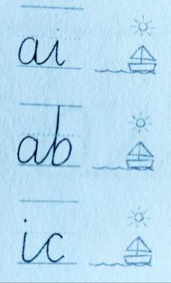
    - the washing line join (horizontal) The arm has three variations:
  - arm to boat

  - arm to sun

  - arm to sister

The washing line join has three variations:
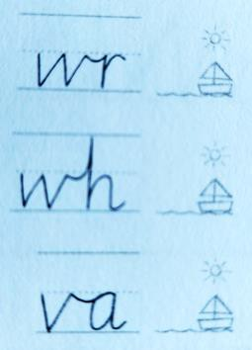
  - washing line to boat

  - washing line to sun

  - washing line to sister

For details of how to form these joins, see:
    - ‘Handwriting Stage 3’ (on the school website)
Appendix 3: number formation
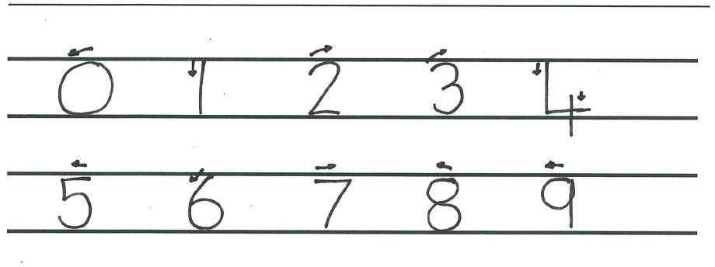
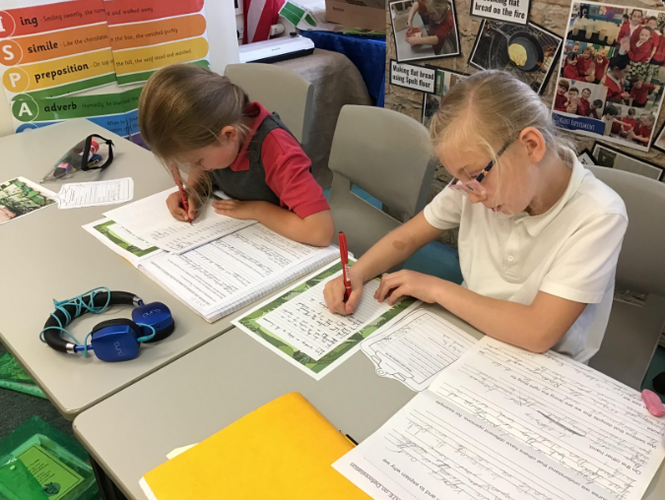

Appendix 4: teaching sequence

Nursery
We aim for the children to:
  - use a comfortable and efficient pencil grip

Through specifically planned activities and experiences, children in our nursery develop the following skills to enable them to become fluent in handwriting:
  - Good gross motor control
  - Good fine motor control
  - A language to talk about shapes and movements in line with the Read Write Inc programme

Handwriting Milestones:

Nursery (3-4 years old)

- Use large-muscle movements to wave flags and streamers, paint and make marks.
- Use one-handed tools and equipment, for example, making snips in paper with scissors.
- Use a comfortable grip with good control when holding pens and pencils
- Shows a preference for a dominant hand.
- Use some of their print and letter knowledge in their early writing. For example: writing a pretend shopping list that starts at the top of the page; write ‘m’ for mummy.
- Write some letters accurately.

Reception
We aim for the children to:
  - use a comfortable and efficient pencil grip
  - write their first name correctly, beginning with a capital letter
  - form lower case letters using the correct sequence of movements, aided by the Read Write Inc. formation speak
  - form capital letters in the correct direction
  - form digits 0-9

Throughout the Early Years Foundation Stage the children will be provided with a range of activities to develop their fine and gross motor skills needed for handwriting.

Children in reception will have the opportunity to practise letter formation in a range of contexts. They are taught how to form letters in line with the phonics programme. They are not taught to join at this stage. When teaching children digraphs, emphasis should not be placed on joining letters but this can be modelled and discussed with the children.

Strategies
Children progress best when provided with a variety of different strategies to practise their handwriting, e.g.
  - tracing
  - copying under the teacher’s writing
  - sky writing
  - talking through the letter formation as it is being modelled
  - practice on paper
  - practice in handwriting books

Handwriting Milestones:

Reception (4-5 years old)
- Develop their small motor skills so that they can use a range of tools competently, safely and confidently. Suggested tools: pencils for drawing and writing, paintbrushes, scissors, knives, forks and spoons.
- Use their core muscle strength to achieve a good posture when sitting at a table or sitting on the floor.
- Develop the foundations of a handwriting style which is fast, accurate and efficient.
- Form lower case and capital letters correctly.
- Hold a pencil effectively in preparation for fluent writing – using the tripod grip in almost all cases.
- Write recognisable letters, most of which are correctly formed.

Sequences outlined through the Read Write Inc phonics & letter formation.

Autumn 1 | Spring 1 | Summer 1
The children will be taught:  - the 26 letters | The children will revisit:  - c a o d g q (around letters)  - e f s (curly letters)  - v w x z (zigzag letters)  - 0 6 8 9  - 5  - capital letters for the letters stated above  (Note: letters and numbers with similar movements are grouped together. The similarities should  be discussed with the children.) | The children will revisit:  - c a o d g q (around letters)  - e f s (curly letters)  - v w x z (zigzag letters)  - 0 6 8 9  - 5  - capital letters for the letters stated above  (Note: letters and numbers with similar movements are grouped together. The similarities should  be discussed with the children.)
Autumn 2 | Spring 2 | Summer 2
The children will be taught:  - the 26 letters  - numbers 0 – 9  (Note: letters and numbers with similar movements are grouped together. The similarities should be discussed with the children.) | The children will revisit:  - l t b p k h I j m n r u k (down letters)  - 2 3  - 1 4 7  - capital letters for the letters stated above  (Note: letters and numbers with similar movements are grouped  together. The similarities should be discussed with the children.) | The children will revisit:  - l t b p k h I j m n r u k (down letters)  - 2 3  - 1 4 7  - capital letters for the letters stated above  (Note: letters and numbers with similar movements are grouped  together. The similarities should be discussed with the children.)

Year 1
We aim for the children to:
  - sit correctly at a table, holding a pencil comfortably and correctly
  - begin to form lower case letters in the correct direction, starting and finishing in the right place
  - form capital letters correctly
  - form digits 0 to 9 correctly
  - understand which letters belong to which handwriting ‘families’ (i.e. letters that are formed in similar ways) and to practise these

Handwriting Milestones

Year 1, Age 5–6

Pupils should be taught to:
• sit correctly at a table, holding a pencil comfortably and correctly
• begin to form lower-case letters in the correct direction, starting and finishing in the right place
• form capital letters
• form digits 0–9
• understand which letters belong to which handwriting ‘families’ (i.e. letters that are formed in similar ways) and to practise these.

Handwriting requires frequent and discrete, direct teaching. Pupils should be able to form letters correctly and confidently. The size of the writing implement (pencil, pen) should not be too large for a young pupil’s hand. Whatever is being used should allow the pupil to hold it easily and correctly so that bad habits are avoided.
Left-handed pupils should receive specific teaching to meet their needs.

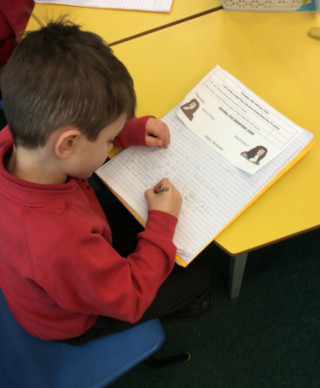

In Year 1, the children have daily handwriting practice. Sequences below are outlined through the Read Write Inc phonics & letter formation.

Autumn 1 | Spring 1 | Summer 1
The children will revisit:  - c o a d g q (around letters)  - l t b p k h (down letters)  - 0 6 8 9  - 2 3  - 5  - capital letters for the letters stated above  Handwriting may also be linked to spelling patterns.  (Note: letters and numbers with similar movements are grouped together. The similarities should  be discussed with the children.) | The children will revisit:  - c o a d g q (around letters)  - l t b p k h (down letters)  - 0 6 8 9  - capital letters for the letters stated above  Handwriting may also be linked to spelling patterns.  (Note: letters and numbers with similar movements are grouped together. The similarities should be discussed with the children.) | The children will revisit:  - c o a d g q (around letters)  - l t b p k h (down letters)  - 0 6 8 9  - capital letters for the letters stated above  Handwriting may also be linked to spelling patterns.  (Note: letters and numbers with similar movements are grouped together. The similarities should be discussed with the children.)
Autumn 2 | Spring 2 | Summer 2
The children will revisit:  - i j m n r u y (down letters)  - v w x z (zigzag letters)  - e f s (curly letters)  - 1 4 7  - capital letters for the letters stated above  Handwriting may also be linked to spelling patterns.  (Note: letters and numbers with similar movements are grouped together. The similarities should be discussed with the children.) | The children will revisit:  - i j m n r u y (down letters)  - v w x z (zigzag letters)  - e f s (curly letters)  - 1 4 7  - 2 3  - 5  - capital letters for the letters stated above  Handwriting may also be linked to spelling patterns.  (Note: letters and numbers with similar movements are grouped together. The similarities should  be discussed with the children.) | The children will revisit:  - i j m n r u y (down letters)  - v w x z (zigzag letters)  - e f s (curly letters)  - 1 4 7  - 2 3  - 5  - capital letters for the letters stated above  Handwriting may also be linked to spelling patterns.  (Note: letters and numbers with similar movements are grouped together. The similarities should  be discussed with the children.)

Year 2
We aim for the children to:
  - sit correctly at a table, holding a pencil comfortably and correctly
  - form lower case letters of the correct size relative to one another
  - start using some of the diagonal and horizontal strokes needed to join letters and understand which letters, when adjacent to one another, are best left unjoined *
  - write capital letters and digits of the correct size, orientation and relationship to one another and to lower case letters
  - use spacing between words that reflects the size of the letters.

- Read Write Inc gives two options about joining some letters – see ’Handwriting Stage 3’ (on the school website).

Handwriting Milestones

Year 2, Age 6–7

Pupils should be taught to:
• form lower-case letters of the correct size relative to one another
• start using some of the diagonal and horizontal strokes needed to join letters and understand which letters, when adjacent to one another, are best left un-joined
• write capital letters and digits of the correct size, orientation and relationship to one another and to lower case letters
• use spacing between words that reflects the size of the letters.

Pupils should revise and practise correct letter formation frequently. They should be taught to write with a joined style as soon as they can form letters securely with the correct orientation.
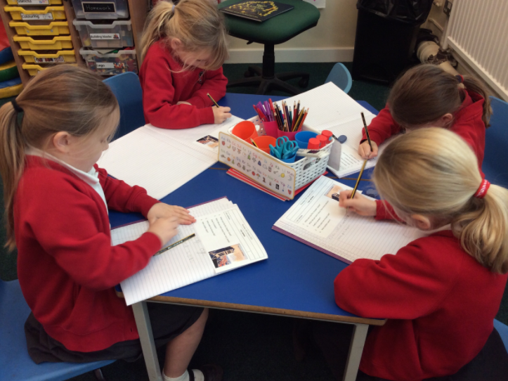

In Year 1, the children have daily handwriting practice. Sequences below are outlined through the Read Write Inc phonics & letter formation.

Autumn 1 | Spring 1 | Summer 1
The children will revisit:  - c a o d g q (around letters)  - l t b p k h I j m n r u k (down letters)  - e f s (curly letters)  - v w x z (zigzag letters)  - capital letters  - 0 - 9  Handwriting will also be linked to spelling patterns. | The children will be taught horizontal joins (washing line joins)  - washing line to boat  - washing line to sun  - washing line to sister  - break letters: q, x, z  - 0-9  - capital letters  Handwriting will also be linked to spelling patterns. | The children will revise horizontal joins (washing line joins):  - washing line to boat  - washing line to sun  - washing line to sister  - break letters: q, x, z  - 0-9  - capital letters  Handwriting will also to be linked to spelling patterns.
Autumn 2 | Spring 2 | Summer 2
The children will be taught to form diagonal joins (arm joins):  - arm to boat  - arm to sun  - arm to sister  They will revisit the correct formation of numbers.  Handwriting will also be linked to spelling patterns. | The children will revise diagonal joins (arm joins):  - arm to boat  - arm to sun  - arm to sister  - break letters: q, x, z  - 0-9  - capital letters  Handwriting will also be linked to spelling patterns. | The children will revise diagonal joins (arm joins):  - arm to boat  - arm to sun  - arm to sister  - break letters: q, x, z  - 0-9  - capital letters  Handwriting will also be linked to spelling patterns.

Years 3 and 4
We aim for the children to:
  - sir correctly at a table, holding a pencil comfortably and correctly
  - use the diagonal and horizontal strokes that are needed to join letters and understand which letters, when adjacent to one another, are best left unjoined
  - increase the legibility, consistency and quality of their handwriting (for example, by ensuring that the downstrokes of letters are parallel and equidistant; that lines of writing are spaced sufficiently so that the ascenders and descenders of letters do not touch)
  - increase the fluency with which they are able to write what they say

In Years 3 and 4, handwriting is taught in discrete sessions 2 x 15 mins weekly as a minimum. The teaching of handwriting is also linked to the spellings being taught.

Handwriting Milestones

Years 3–4, Age 7–9

Pupils should be taught to:
• use the diagonal and horizontal strokes that are needed to join letters and understand which letters, when adjacent to one another, are best left un-joined
• increase the legibility, consistency and quality of their handwriting (for example, by ensuring that the downstrokes of letters are parallel and equidistant; that lines of writing are spaced sufficiently so that the ascenders and descenders of letters do not touch).

Pupils should be using joined handwriting throughout their independent writing. Handwriting should continue to be taught, with the aim of increasing the fluency with which pupils are able to write down what they want to say. This, in turn, will support their composition and spelling.
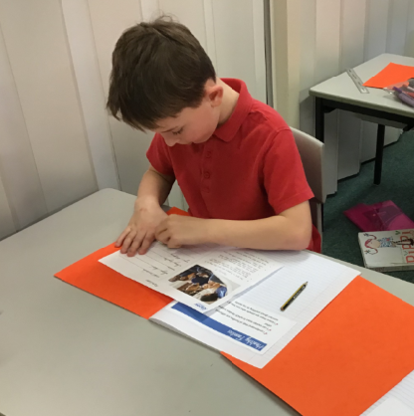

Years 3 and 4
Autumn 1 | Spring 1 | Summer 1
The children will revisit:  - washing line to boat  - washing line to sun  - washing line to sister  - 0-9  - capital letters  Handwriting will also be linked to spelling patterns | The children will revisit:  - washing line to boat  - washing line to sun  - washing line to sister  - 0-9  - capital letters  Handwriting will also be linked to spelling patterns | The children will revisit:  - washing line to boat  - washing line to sun  - washing line to sister  - 0-9  - capital letters  Handwriting will also be linked to spelling patterns
Autumn 2 | Spring 2 | Summer 2
The children will revisit:  - arm to boat  - arm to sun  - arm to sister  - break letters: q, x, z *  - capital letters  Handwriting will also be linked to spelling patterns | The children will revisit:  - arm to boat  - arm to sun  - arm to sister  - break letters: q, x, z  - capital letters  Handwriting will also be linked to spelling patterns | The children will revisit:  - arm to boat  - arm to sun  - arm to sister  - break letters: q, x, z  - capital letters  Handwriting will also be linked to spelling patterns

- Read Write Inc gives two options about joining some letters – see ’Handwriting Stage 3’ (on the school website).

Years 5 and 6
We aim for the children to:
  - write legibly, fluently and with increasing speed by:
- using the basic joins confidently when writing
- making choices about their own personal writing style
- making decisions about when it is best to leave writing un-joined, e.g. when labelling a diagram or filling in a form
- choosing which shape of a letter to use when given choices and deciding whether or not to join specific letters (as long as they are consistent in their choices)
- choosing the writing implement that is best suited for a task
  - be clear about what standard of handwriting is appropriate for a particular task, e.g. quick notes or a final handwritten version

In Year 5 & 6, handwriting is taught in discrete sessions 2 x 15 mins weekly as a minimum using the teaching sequences for previous year groups according to the needs to the children in the class. The teaching of handwriting is also linked to the spellings being taught.

Handwriting Milestones

Years 5–6, Age 10–11

Pupils should be taught to write legibly, fluently and with increasing speed by:
• choosing which shape of a letter to use when given choices and deciding whether or not to join specific letters
• choosing the writing implement that is best suited for a task.
Pupils should continue to practise handwriting and be encouraged to increase the speed of it, so that problems with forming letters do not get in the way of their writing down what they want to say. They should be clear about what standard of handwriting is appropriate for a particular task, for example, quick notes or a final handwritten version. They should also be taught to use an un-joined style, for example, for labelling a diagram or data, writing an email address, or for algebra; and capital letters, for example, for filling in a form.

