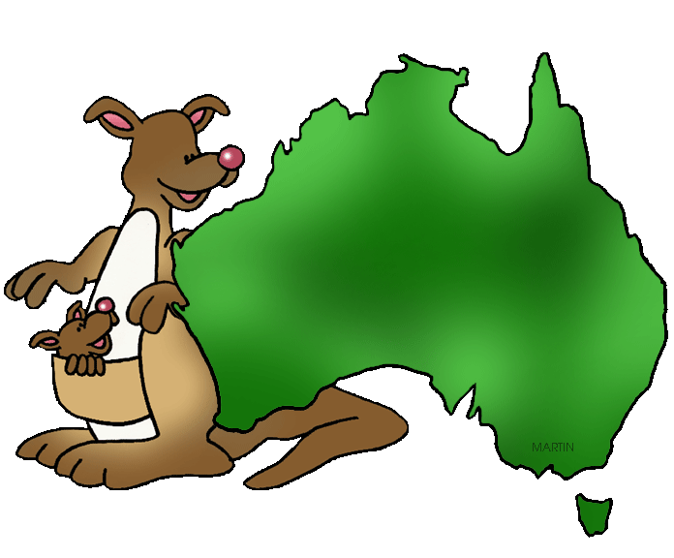




Newbald Primary School

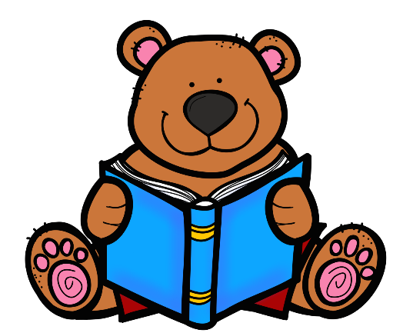
Reading Framework

for Teaching



Newbald Primary School Aims for Reading
At Newbald Primary school, we intend that:
- All children know all phonics sounds by the end of Year 1 - There is no alternative to phonics. - All children make rapid catch up if needed
- All children to become confident, fluent readers and develop an enjoyment & love for reading.
- All children to be exposed to a wide vocabulary & have a deep understanding of texts that they read including knowledge of inference, prediction & retrieval.
- All children to read a variety of genres fiction, non-fiction & poetry that also expands the children’s wider curriculum knowledge
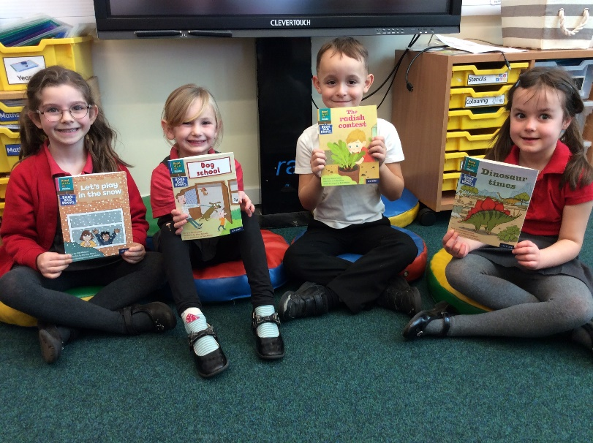
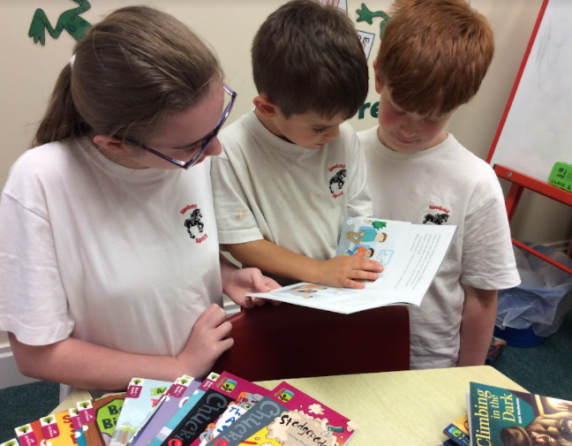
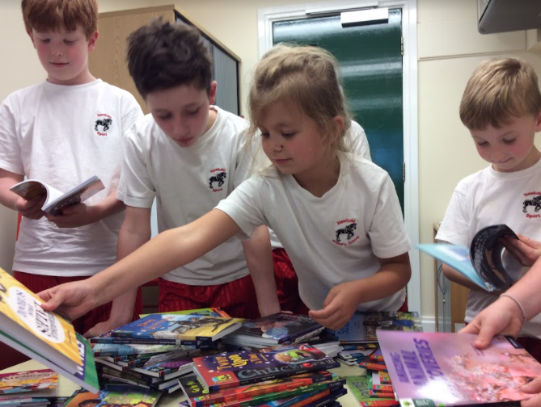

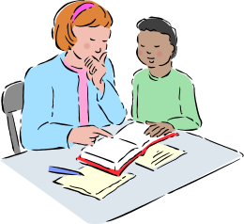


Key learning and teaching points:

- Reading and writing need to be promoted, encouraged and implemented across the curriculum
- Reading is of the highest priority and each class will have timetabled activities throughout the week to ensure that reading skills are taught to the highest standard.

  - Daily Phonics (In Key Stage 1)
  - In Key Stage 1, separate phonics planning needs to be in place, based on 30-minute daily sessions
  - Teaching of phonics will be consistent from entry until the end of Key Stage 1
  - Teaching of phonics will include dictation and application time to apply phonetical knowledge to reading and spelling. This can be part of the daily phonics allocated time, but also a weekly session directed for handwriting, phonics application, spelling and dictation
  - TA support & intervention must be directed at the earliest possible point to any child who is in need of extra help with phonics. Every child is expected to know their phonics sounds and apply these to help them read and spell at Newbald Primary School
  - Reading and comprehension skills can be developed through well-planned speaking and listening activities, including drama, role play, hot seating, debate etc.
  - Any child who is in need of extra phonics tuition will receive intervention beyond KS1 if needed.

  - Home Reading Books (In Pre-School & Foundation Stage & KS1)
  - 2/3 Reading books will be allocated to children weekly and must be related and match their phonics knowledge & reading ability
  - Phonics skills will be regularly assessed and reading books will be adjusted to suit
  - Children should be able to read their allocated ‘scheme’ book fluently
  - Children should be encouraged to re-read books multiple times
  - Weekly, children in Foundation Stage & KS1 will also be allocated a ‘together time’ book. This is a book with more adventurous vocabulary for an adult to read with the child. Children will be encouraged to share these books multiple times.
  - Reading books will be changed on a weekly basis
  - Home Reading Books (In Key Stage 2)
  - Children that are still mastering their phonics knowledge will continue to be matched to ‘scheme books’ that matches their reading ability enabling the children to read fluently and confidently.
  - Children that have mastered phonetical sound application will continue to be given longer ‘scheme’ books, but will be encouraged to move onto own choice books (organised by year group)
  - Free choice books will be available for each class, so that they can read for pleasure during designated time in school and at home. Children will be encouraged to also bring their own books should they choose to do so.
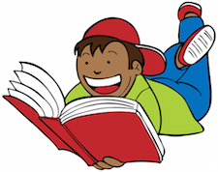
  - Children are encouraged to read every day (including weekends) Achievable targets (such as 4 times a week) is set for reluctant readers.
  - Reading books will be changed on a weekly basis

  - Guided Reading
  - In Key Stage 2, daily (Mon – Thurs) 30-minute reading activities need to be planned related to a novel or class book.
  - These books can be related to a topic, theme or genre being learnt about at that time or the books can be a contrast to the current topic ensuring that true comprehension skills are being used rather than relying upon topical knowledge.
  - Books for guided reading will be chosen by the staff and are listed as part of the long-term plan.
  - A range of questioning will be used to ensure that all areas are covered and regularly practiced. This includes:
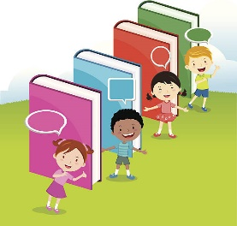
    - Vocabulary questions
    - Inference questions
    - Prediction questions
    - Explain questions (Including Comparing, contrasting & giving own opinions)
    - Retrieval questions
    - Summary& Sequence questions
  - Questions related to guided reading activities will be answered in a ‘short’ form and do not need to be answered using full sentences or copying out questions maximising reading and response time.

- In Key Stage 1, daily (Mon – Fri) 20 minute responding to reading activities need to be planned related to a novel or class book.
  - These books can be related to a topic, theme or genre being learnt about at that time or the books can be a contrast to the current topic ensuring that true comprehension skills are being used rather than relying upon topical knowledge.
  - Books will also form part of ‘story time’ where children will have texts read to them by an adult.
  - Books for guided reading will be chosen by the staff and are listed as part of the long-term plan.
  - A range of questioning will be used to ensure that all areas are covered and regularly practiced. This includes:
    - Vocabulary questions
    - Inference questions
    - Prediction questions
    - Explain questions (Including Comparing, contrasting & giving own opinions)
    - Retrieval questions
    - Summary& Sequence questions
  - Questions related to guided reading activities will be answered in a ‘short’ form and do not need to be answered using full sentences or copying out questions maximising reading and response time.
  - Written comprehension exercises are an essential part of the two-week planning cycle from year 1 upwards
  - Comprehension tasks form an essential part of the planning cycle introducing the children to outstanding examples of text related to the writing genre the children will be expected to be writing over the fortnight of learning
  - These activities must be related to the current topic or theme
  - Features of the genre can be learnt and studied as part of understanding the text to a deeper level.
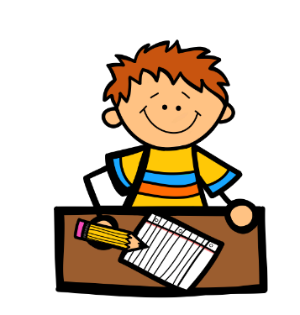
  - A range of questioning will be used to ensure that all areas are covered and regularly practiced. This includes:
    - Vocabulary questions
    - Inference questions
    - Prediction questions
    - Explain questions (Including Comparing, contrasting & giving own opinions)
    - Retrieval questions
    - Summary& Sequence questions
  - Although differentiated to ensure all children can achieve, questions related to lesson comprehension tasks will be answered in a ‘longer’ form and must be answered using full sentences as part of a wider grammatical focus.
  - There is never a need to copy out questions maximising reading and response time.
  - Reading and comprehension is interwoven through all areas of the curriculum. Skills can be developed through cross curricular texts, well-planned speaking and listening activities, including drama, role play, hot seating, debate etc
  - Reading for Pleasure
  - Each class will be allocated daily time to read for pleasure. (Usually 10 minutes after lunch)
  - Children will choose a book of their choice.
  - Children will be recommended books by staff that may develop and foster a love for reading

  - Reading with an Adult in school / Bark and Read
  - Where possible Adults will listen to children read as often as possible.
  - Adults can include teachers, TAs, governors, other members of staff and volunteers
  - We will aim for an adult to listen to all children read each week. This may be 1-1 reading time, part of a guided reading activity or wider reading task
  - All children attending the after-school club (daily) will have the opportunity to read to an adult
  - Each class will have a ‘priority reading list’, so that adults reading with children can target poorer readers
  - When reading with an adult, the adult will question the reader to challenge comprehension skills
  - Scheme books will be used for 1-1 reading with adults in Foundation - KS1
  - A variety of reading resources will be used for 1-1 reading with adults including: scheme books, reading for pleasure choice books, inference cards and reading mats. -Questioning the children about what they have read is imperative to challenge and extend comprehension skills
  - Weekly, class teachers will nominate a group of children to read with Murphy, the school dog.
  - Over the year each child will have time to read with Murphy
  - This Bark & Read session will be led with an Adult and is designed to boost reading aloud for reluctant readers
  - Class Story Time
  - Daily each class will enjoy some story time where the class teacher reads to their class.
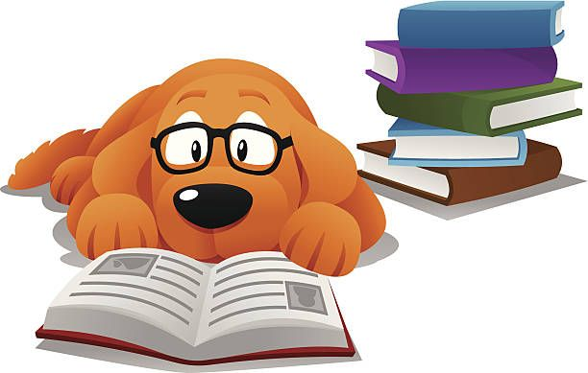
  - The class teacher will choose age appropriate books that they are passionate about to show the love for reading that we promote in the school
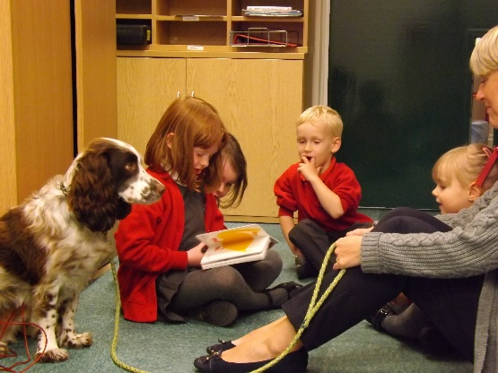

  - Reading Buddies
  - Weekly, time will be allocated for children across the whole school are paired to read to one another.
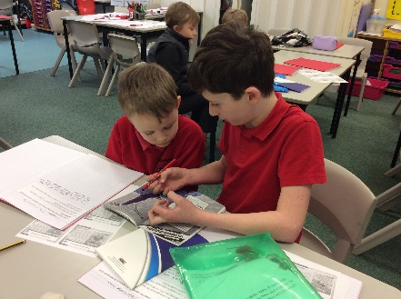
  - Scheme books will be chosen for younger readers to read and reading for pleasure (Free choice) books can be chosen by the younger child for the older child to read to the younger child.
  - Predominately, older children will listen to younger children read.
  - Older children will ask relevant questions about the book they are listening to.
  - Books will be encouraged to be re-read multiple times

  - Wider Reading Strategies
  - Staff will demonstrate a passion and a love for reading recommending authors and books to individual children
  - Staff will prioritise intervention for decoding or comprehension as a priority and allocate TA time to ensure that children make good progress to ‘catch up’
  - Each class will adopt a personalised reading reward scheme to encourage reading out of school
  - Each class will have a reading display in their classroom that promotes reading and forms part of the class reading reward scheme
  - Children will be encouraged to talk positively about books they have read and give recommendations to each other
  - Annually the school will celebrate World Book Day, where the school will promote the love of reading. Dress up as much-loved book characters, write character descriptions, write book reviews and design new book covers
  - The school will purchase books as prizes for competitions in school to promote the love of books
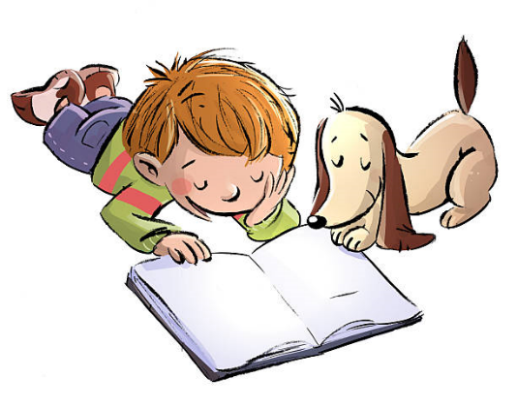
  - The school will give an encyclopaedia as a leaving gift to outgoing Year 6s

  - High Ability Readers
  - High ability readers will be identified by the class teacher to have extra intervention work to challenge and extend
  - High ability readers will have differentiated in class comprehension activities to challenge
  - Recommendation of reading books identified by staff to further an interest for individuals including books by celebrated classic authors such as Dickens, Bronte, Austen etc
  - Recommendation of genres to further the child’s interest range such as mystery novels, fantasy, nonfiction, poetry or historical fiction.
  - High Ability readers are encouraged to present, recommendations of books that they have enjoyed reading to the rest of the school in a multi media way e.g. video blogging / leading assemblies /creating a PowerPoint presentation etc
  - Assessment
  - Teachers will have multiple strategies for formative and summative assessment
  - Summative PIRA tests – From Year 1 onwards
  - Regular summative Phonics assessment of taught sounds & skills
  - Regular formative assessment through questioning and through observation and marking of ongoing provision
  - Formative assessment through 1-1 reading and response questioning


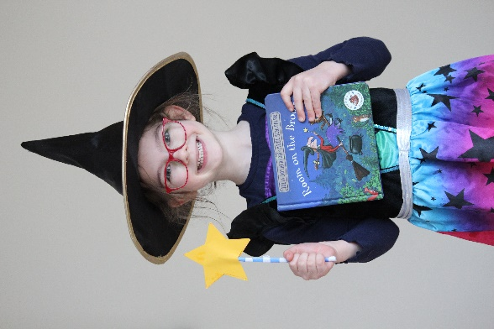
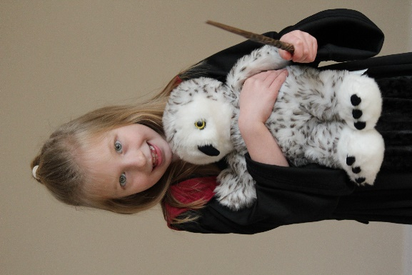

Reading Progression of Knowledge & Skills
*Updated to include EYFS 2021 statements
Reading – Word Reading | EYFS | KS1 |  | KS2
Reading – Word Reading | Three and Four-Year-Olds  Reception  Early Learning Goals | Year 1 | Year 2 | Year 3 | Year 4 | Year 5 | Year 6
Phonics and Decoding | Develop their phonological awareness, so that they can:  - spot and suggest rhymes  - count or clap syllables in words  - recognise words with the same initial sound, such as money and mother  Read individual letters by saying the sounds for them.  Blend sounds into words, so that they can read short words made up of letter-sound correspondences.  Read some letter groups that each represent one sound and say sounds for them.  Read simple phrases and sentences made up of words with known letter-sound correspondences and, where necessary, a few exception words.  Say a sound for each letter in the alphabet and at least 10 digraphs.  Read words consistent with their phonic knowledge by sound-blending.  Read aloud simple sentences and books that are consistent with their phonic knowledge, including some common exception words. | To apply phonic knowledge and skills as the route to decode words.  To blend sounds in unfamiliar words using the GPCs that they have been taught.  To respond speedily, giving the correct sound to graphemes for all of the 40+ phonemes.  To read words containing taught GPCs.  To read words containing -s, -es, -ing,  -ed and -est endings.  To read words with contractions, e.g. I’m, I’ll and we’ll. | To continue to apply phonic knowledge and skills as the route to decode words until automatic  decoding has become embedded and reading is fluent.  To read accurately by blending the sounds in words that contain the graphemes taught so far,  especially recognising alternative sounds for graphemes.  To accurately read most words of two or more syllables.  To read most words containing common suffixes.* | To use their phonic knowledge to decode quickly and accurately (may still need support to read longer unknown words).  To apply their growing knowledge of root words and prefixes, including  in-, im-, il-, ir-, dis-, mis-,  un-, re-, sub-, inter-, super-, anti- and auto- to begin to read aloud.*  To apply their growing knowledge of root words and suffixes/word endings, including -ation,  -ly, -ous, -ture, -sure, -sion,  -tion, -ssion and -cian, to begin to read aloud.* | To read most words fluently and attempt to decode any unfamiliar words with increasing speed and skill.  To apply their knowledge of root words, prefixes and suffixes/word endings to read aloud fluently.* | To read most words fluently and attempt to decode any unfamiliar words with increasing speed and skill, recognising their meaning through contextual cues.  To apply their growing knowledge of root words, prefixes and suffixes/ word endings, including  -sion, -tion, -cial, -tial,  -ant/-ance/-ancy, -ent/- ence/-ency, -able/-ably and -ible/ibly, to read aloud fluently.* | To read fluently with full knowledge of all Y5/ Y6 exception words, root words, prefixes,  suffixes/word endings* and to decode any unfamiliar words with increasing speed and skill, recognising their meaning through contextual cues.

Reading – Word Reading | EYFS | KS1 |  | KS2
Reading – Word Reading | Three and Four-Year-Olds  Reception  Early Learning Goals | Year 1 | Year 2 | Year 3 | Year 4 | Year 5 | Year 6
Common Exception Words | Read a few common exception words matched to the school’s phonic programme.  To read some common  irregular words. | To read Y1 common exception words, noting unusual correspondences between spelling and sound and where these occur in words. | To read most Y1 and Y2 common exception words*, noting unusual correspondences  between spelling and sound and where these occur in the word. | To begin to read Y3/Y4 exception words.* | To read all Y3/Y4 exception words*, discussing the unusual correspondences between spelling and these occur in the word. | To read most Y5/ Y6 exception words,  discussing the unusual correspondences between spelling and sound and where these occur in the word.

Fluency | Understand the five key concepts about print:  print has meaning  - the names of different parts of a book  - print can have different purposes  - page sequencing  - we read English text from left to right and from top to bottom  Blend sounds into words, so that they can read short words made up of letter-sound correspondences.  Read simple phrases and sentences made up of words with known letter-sound correspondences and, where necessary, a few exception words.  Re-read books to build up their confidence in word reading, their fluency and their understanding and enjoyment.  Read aloud simple sentences and books that are consistent with their phonic knowledge, including some common exception words. | To accurately read texts that are consistent with their developing phonic knowledge, that do not require them to use other strategies to work out words.  To reread texts to build up fluency and confidence in word reading. | To read aloud books (closely matched to their improving phonic  knowledge), sounding out unfamiliar  words accurately, automatically and without undue hesitation.  To reread these books to build up fluency and  confidence in word reading.  To read words accurately and fluently without overt sounding and blending, e.g. at over 90 words per minute, in age-appropriate texts. | At this stage, teaching comprehension skills should be taking precedence over teaching word reading and fluency specifically. Any focus on word reading should support the development of vocabulary.
Reading – Word Reading | EYFS | KS1 |  | KS2
 | Three and Four-Year-Olds  Reception  Early Learning Goals | Year 1 | Year 2 | Year 3 | Year 4 | Year 5 | Year 6
Reading – Comprehension | EYFS | KS1 |  | KS2
Reading – Comprehension | Three and Four-Year-Olds  Reception  Early Learning Goals | Year 1 | Year 2 | Year 3 | Year 4 | Year 5 | Year 6
Understanding and Correcting Inaccuracies | Enjoy listening to longer stories and can remember much of what happens.  Understand ‘why’ questions, like: “Why do you think the caterpillar got so fat?”  Be able to express a point of view and debate when they disagree with an adult or a friend, using words as well as actions  .  Listen to and talk about stories to build familiarity and understanding.  Listen to and talk about selected non-fiction to develop a deep familiarity with new knowledge and vocabulary.  Demonstrate understanding of what has been read to them by retelling stories and narratives using their own words and recently introduced vocabulary. | To check that a text makes sense to them as they read and to self- correct. | To show understanding by drawing on what they already know or on background information  and vocabulary provided by the teacher.  To check that the text makes sense to them as they read and to correct inaccurate reading.

Reading – Comprehension | EYFS | KS1 |  | KS2
Reading – Comprehension | Three and Four-Year-Olds  Reception  Early Learning Goals | Year 1 | Year 2 | Year 3 | Year 4 | Year 5 | Year 6
Comparing, Contrasting and Commenting | Be able to express a point of view and debate when they disagree with an adult or a friend, using words as well as actions.  Compare and contrast characters from stories, including figures from the past.  Retell the story, once they have developed a deep familiarity with the text; some as exact repetition and some in their own words.  Listen attentively and respond to what they hear with relevant questions, comments and actions when being read to and during whole class discussions and small group interactions.  Offer explanations for why things might happen, making use of recently introduced vocabulary from stories, non-fiction, rhymes and poems when appropriate.  Anticipate (where appropriate) key events in stories. | To listen to and discuss a wide range of fiction, non-fiction and poetry at a level beyond that at which they can read independently.  To link what they have read or have read to them to their own experiences.  To retell familiar stories in increasing detail.  To join in with discussions about a text, taking turns and listening to what others say.  To discuss the significance of titles and events. | To participate in discussion about books, poems and other works that are read to them  (at a level beyond at which they can read independently) and those that they can read for themselves, explaining their understanding and expressing their views.  To become increasingly familiar with and to retell a wide range of stories, fairy stories and traditional tales.  To discuss the sequence of events in books and how items of information are related. | To recognise, listen to and discuss a wide range of fiction, poetry, plays, non-fiction and  reference books or textbooks.  To use appropriate terminology when discussing texts (plot, character, setting). | To discuss and compare texts from a wide variety of genres and writers.  To read for a range of purposes.  To identify themes and conventions in a wide range of books.  To refer to authorial style, overall themes (e.g. triumph of good over evil) and  features (e.g. greeting in letters, a diary written in the first person or the use of presentational devices such as numbering and headings). | To read a wide range of genres, identifying the characteristics of text types (such as the use of the first person in writing diaries and autobiographies) and differences between text types.  To participate in discussions about books that are read to them and those they can read for  themselves, building on their own and others’ ideas and challenging views courteously.  To identify main ideas drawn from more than one paragraph and to | To read for pleasure, discussing, comparing and evaluating in depth across a wide range of genres, including myths, legends, traditional stories, modern fiction, fiction from our literary heritage and books from other cultures and traditions.  To recognise more complex themes in what they read (such as loss or heroism).  To explain and discuss their understanding of what they have read, including through formal presentations and debates,

Comparing, Contrasting and Commenting (Continued) | Demonstrate understanding of what has been read to them by retelling stories and narratives using their own words and recently introduced vocabulary. |  | To recognise simple recurring literary language in stories and poetry.  To ask and answer questions about a text.  To make links between the text they are reading and other texts they have read (in texts that they can read independently). |  | To identify how language, structure and presentation contribute to meaning.  To identify main ideas drawn from more than one paragraph and summarise these. | summarise these.  To recommend texts to peers based on personal choice. | maintaining a focus on the topic and using notes where necessary.  To listen to guidance and feedback on the quality of their explanations and contributions to discussions and to  make improvements when participating in discussions.  To draw out key information and to summarise the main ideas in a text.  To distinguish independently between statements of fact  and opinion, providing reasoned justifications for their views.  To compare characters, settings and themes within a text and across more than one text.

Reading – Comprehension | EYFS | KS1 |  | KS2
Reading – Comprehension | Three and Four-Year-Olds  Reception  Early Learning Goals | Year 1 | Year 2 | Year 3 | Year 4 | Year 5 | Year 6
Words in Context and Authorial Choice | Use a wider range of vocabulary.  Engage in extended conversations about stories, learning new vocabulary.  Learn new vocabulary.  Use new vocabulary throughout the day.  Retell the story, once they have developed a deep familiarity with the text; some as exact repetition and some in their own words.  Use new vocabulary in different contexts.  Listen to and talk about selected non-fiction to develop a deep familiarity with new knowledge and vocabulary.  Offer explanations for why things might happen, making use of recently introduced vocabulary from stories, non-fiction, rhymes and poems when appropriate.  Demonstrate understanding of what has been read to them by retelling stories and narratives using their own words and recently introduced vocabulary.  Use and understand recently introduced vocabulary during discussions about stories, non-fiction, rhymes and poems and during role play. | To discuss word meaning and link new meanings to those already known. | To discuss and clarify the meanings of words, linking new meanings to known vocabulary.  To discuss their favourite words and phrases. | To check that the text makes sense to them, discussing their  understanding and explaining the meaning of words in context.  To discuss authors’ choice of words and phrases for effect. | Discuss vocabulary used to capture readers’ interest and imagination. | To discuss vocabulary used by the author to create effect including figurative language.  To evaluate the use of authors’ language and explain how it has created an impact on  the reader. | To analyse and evaluate the use of language, including figurative language and how it is used for effect, using technical terminology such as metaphor, simile, analogy, imagery, style and effect.

Reading – Comprehension | EYFS | KS1 |  | KS2
Reading – Comprehension | Three and Four-Year-Olds  Reception  Early Learning Goals | Year 1 | Year 2 | Year 3 | Year 4 | Year 5 | Year 6
Inference and Prediction | Understand ‘why’ questions, like: “Why do you think the caterpillar got so fat?”  Offer explanations for why things might happen, making use of recently introduced vocabulary from stories, non-fiction, rhymes and poems when appropriate.  Anticipate (where appropriate) key events in stories. | To begin to make simple inferences.  To predict what might happen on the basis of what has been read so far. | To make inferences on the basis of what is being said and done.  To predict what might happen on the basis of what has been read so far in a text. | To ask and answer questions appropriately, including some simple inference questions based on characters’ feelings, thoughts and motives.  To justify predictions using evidence from the text. | To draw inferences from characters’ feelings, thoughts and motives that justifies their actions, supporting their views with evidence from the text.  To justify predictions from details stated and implied. | To draw inferences from characters’ feelings, thoughts and motives.  To make predictions based on details stated and implied, justifying them in detail with evidence from the text. | To consider different accounts of the same event and to discuss viewpoints (both of authors and of fictional characters).  To discuss how characters change and develop through texts by drawing inferences based on indirect clues.

Reading – Comprehension | EYFS |  |  | KS2
Reading – Comprehension | Three and Four-Year-Olds  Reception  Early Learning Goals | Year 1 | Year 2 | Year 3 | Year 4 | Year 5 | Year 6
Poetry and Performance | Sing a large repertoire of songs.  Know many rhymes, be able to talk about familiar books, and be able to tell a long story.  Take part in simple pretend play, using an object to represent something else even though they are not similar.  Begin to develop complex stories using small world equipment like animal sets, dolls and dolls houses, etc.  Remember and sing entire songs.  Sing the melodic shape (moving melody, such as up and down and down and up) of familiar songs.  Create their own songs, or improvise a song around one they know.  Engage in story times.  Retell the story, once they have developed a deep familiarity with the text; some as exact repetition and some in their own words.  Learn rhymes, poems and songs.  Sing in a group or on their own, increasingly matching the pitch and following the melody.  Develop storylines in their pretend play.  Demonstrate understanding of what has been read to them by retelling stories and narratives using their own words and recently introduced vocabulary.  Make use of props and materials when role playing characters in narratives and stories.  Invent, adapt and recount narratives and stories with their peers and their teacher.  Perform songs, rhymes, poems and stories with others, and (when appropriate) try to move in time to music. | To recite simple poems by heart. | To continue to build up a repertoire of poems learnt by heart, appreciating these and reciting some with appropriate intonation to make the meaning clear. | To prepare and perform poems and play scripts that show some awareness of the audience when reading aloud.  To begin to use appropriate intonation and volume when reading aloud. | To recognise and discuss some different forms of poetry (e.g. free verse or narrative poetry).  To prepare and perform poems and play scripts with appropriate techniques (intonation, tone, volume and action) to show awareness of the audience when reading aloud. | To continually show an awareness of audience when reading out loud using intonation, tone, volume and action. | To confidently perform texts (including poems learnt by heart) using a wide range of devices to engage the audience and for effect.
KS1

Reading – Comprehension | EYFS |  |  | KS2
Reading – Comprehension | Three and Four-Year-Olds  Reception  Early Learning Goals | Year 1 | Year 2 | Year 3 | Year 4 | Year 5 | Year 6
Non-Fiction | Engage in non-fiction books.  Listen to and talk about selected non-fiction to develop a deep familiarity with new knowledge and vocabulary.  Offer explanations for why things might happen, making use of recently introduced vocabulary from stories, non-fiction, rhymes and poems when appropriate.  Use and understand recently introduced vocabulary during discussions about stories, non-fiction, rhymes and poems and during role play. | To recognise that non- fiction books are often structured in different ways. |  | To retrieve and record information from non- fiction texts. | To use all of the organisational devices available within a non- fiction text to retrieve, record and discuss information.  To use dictionaries to check the meaning of words that they have read. | To use knowledge of texts and organisation devices to retrieve, record and discuss information from fiction and non-fiction texts. | To retrieve, record and present information from non-fiction texts.  To use non-fiction materials for purposeful information retrieval (e.g. in reading history, geography and science textbooks) and in contexts where pupils are genuinely motivated to find out information (e.g. reading information leaflets before a gallery or museum visit or reading a theatre programme or review).
* These are detailed in the word lists within the spelling appendix to the national curriculum (English Appendix 1). Teachers should refer to these to exemplify the words that pupils should be able to read as well as spell.

