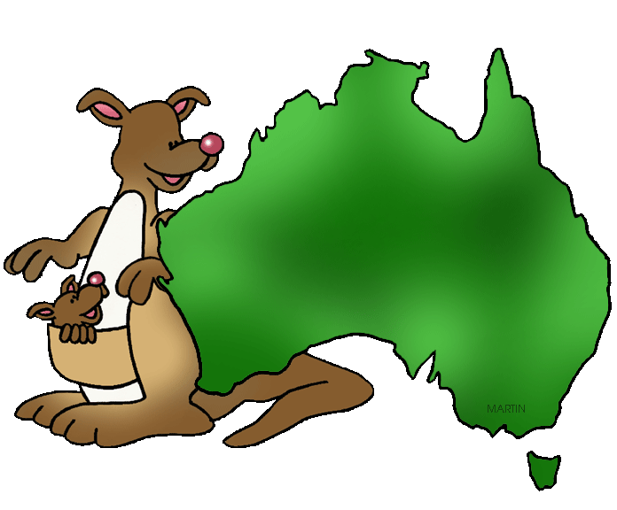


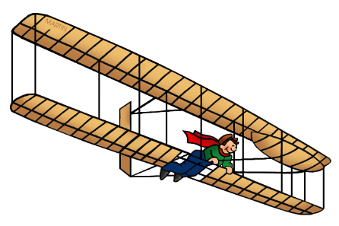



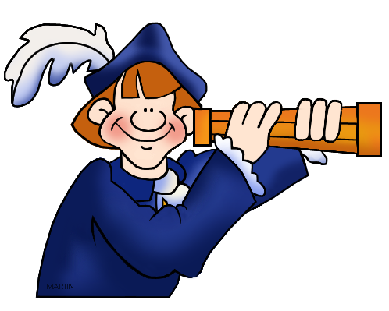
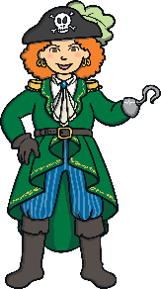
Newbald Primary School
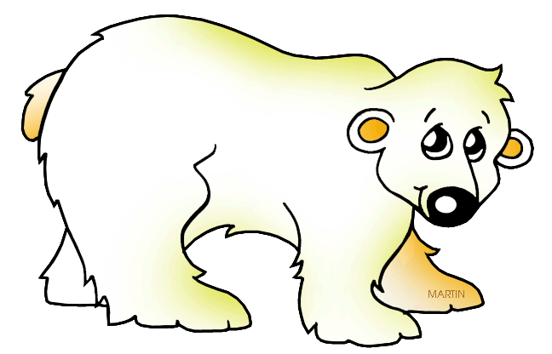
Year 1 & Year 2
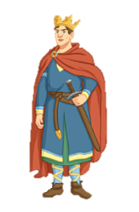
Literacy Framework
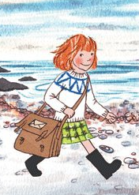
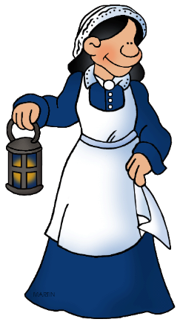
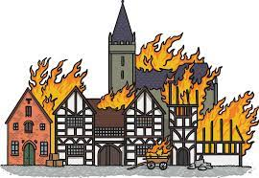
for Teaching
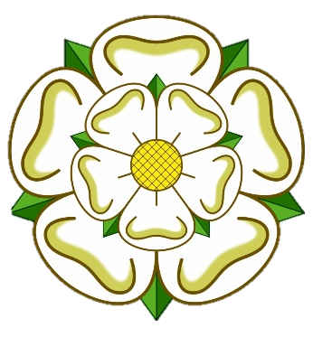

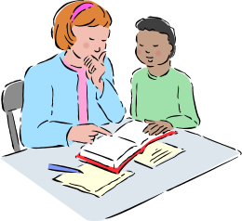



Key learning and teaching points:

- Reading and writing need to be promoted, encouraged and implemented across the curriculum
- Reading is of the highest priority and has its own reading framework (Please see the reading framework for more details)
- There has to be an effective balance of planned word, sentence and text level activities that are linked both to one another and to the current topic
- In Key Stage 1, separate phonics planning needs to be in place, based on 30-minute daily sessions
- Planning should be focused around two-week blocks, where possible (see planning guide below)
- TA support must be incorporated in planning and opportunities provided for them to work with all ability groups
- Reading and comprehension skills can be developed through well-planned speaking and listening activities, including drama, role play, hot seating, debate etc.
- Written comprehension exercises are an essential part of the two-week planning cycle from year 1 upwards
- Weekly spellings should be sent home and results of testing recorded and shared with the children & parents
- Dictionaries and thesauruses need to be easily accessible and spelling logs used systematically and consistently
- High-quality presentation of work is fundamental to raising standards in writing
- In both Key Stages, the school handwriting scheme underpins our school presentation policy and this scheme must be incorporated in weekly planning
- Pupils will use a pencil to write with, until the teacher considers their handwriting neat enough to be done in pen
- Writing target cards need to be used effectively in order that pupils can monitor their own assessment and be encouraged to progress


Two Week Planning Guide

WEEK ONE | Key Stage One |  | Key Stage Two
Monday | Reading/comprehension activity (linked to current topic) | Daily 30 mins. phonics sessions | Comprehension exercise (linked to current topic)
Tuesday | Analysis of current genre | Daily 30 mins. phonics sessions | Analysis of current genre
Wednesday | Phonics application, dictation & handwriting | Daily 30 mins. phonics sessions | Word/Sentence/GPS level activity (linked to current genre)
Thursday | Word/Sentence/GPS level activity | Daily 30 mins. phonics sessions | Word/Sentence/GPS level activity (linked to current genre)
Friday | Writing task | Daily 30 mins. phonics sessions | Writing task

WEEK TWO | Key Stage One |  | Key Stage Two
Monday | Reading/comprehension activity (linked to current book/topic) | Daily 30 mins. phonics sessions | Comprehension exercise (linked to current topic)
Tuesday | Phonics application, dictation & handwriting | Daily 30 mins. phonics sessions | Word/Sentence/GPS level activity (linked to current genre)
Wednesday | Word/Sentence/GPS level activity | Daily 30 mins. phonics sessions | Word/Sentence/GPS level activity (linked to current genre)
Thursday | Draft / Plan for Extended Writing Activity | Daily 30 mins. phonics sessions | Draft / Plan for Extended Writing Activity
Friday | Extended Writing Activity | Daily 30 mins. phonics sessions | Extended Writing Activity


Text Genres

Year | Autumn 1 | Autumn 2 | Spring 1 | Spring 2 | Summer 1 | Summer 2
Year 1 / 2 Cycle 1 | Florence Nightingale & Mary Seacole | Australia & Oceania | Weather & Climate | Explorers | Our Local Area: Yorkshire | Inventors & Inventions
Year 1 / 2 Cycle 1 | Biographies (2wks)  Information (2wks)  Play Scripts (2wks) | Stories From other cultures (2wks)  Postcards (2wks)  Animal information Texts (2wks) | Explanation (2wks)  Instructions (2wks)  Weather Poetry (2wks) | News Reports (2wks)  Historical Adventure Stories (2wks)  Diaries & Letters (2wks) | Stories with familiar settings (2wks)  Information Texts (2wks)  Poetry (Language Play) (1wk) | Persuasive Writing (2wks)  Biographies (2Wks)  Imaginative Fiction Writing (2wks)
Year 1 / 2 Cycle 2 | Transport through time | Polar Regions | Great Fire of London | Pirates & the Oceans | An Island Home | Kings & Queens
Year 1 / 2 Cycle 2 | Labels, lists and captions (2wks)  Biographies (2wks)  Transport Stories (2wks) | Explanation Texts (2wks)  Adventure Stories set in the Polar Regions (2wks)  Poetry (2wks) | Information Texts (2wks)  Diaries & Recounts (2wks)  Play Scripts (2wks) | Information Texts (2wks)  Poems to perform & Sea-Shanties (2wks)  Persuasion (2wks) | Katie Morag Stories (2wks)  Information Texts (2wks)  Postcards (2wks) | Non-Chronological Reports (2wks)  Stories (2wks)  News Reports (2wks)



Year Group Objectives - Year 1

Year | Subject | Aspect | Objective
1 | Writing | Non-negotiables | I can use phonic knowledge to write words that match their spoken sounds and regular words of more than one syllable.
1 | Writing | Non-negotiables | I can read back what I have written.
1 | Writing | Non-negotiables | I can write phase 2 and 3 tricky words and other irregular words.
1 | Writing | Non-negotiables | I can leave space between words.
1 | Writing | Composition – Planning | I can say out loud what I am going to write about.
1 | Writing | Composition – Planning | I can compose a sentence orally before writing it
1 | Writing | Composition – Structure | I can write a story with a beginning, middle and end.
1 | Writing | Composition – Structure | I can write sentences that are sequenced to form a short narrative, after discussion with my teacher.
1 | Writing | Composition – Vocabulary | I can use vocabulary provided by the teacher in my writing.
1 | Writing | Composition – Vocabulary | I can use some vocabulary from familiar stories in my own writing.
1 | Writing | Composition – Grammar and Punctuation | I can demarcate some sentences with capital letters and full stops.
1 | Writing | Composition – Grammar and Punctuation | I am beginning to punctuate sentences with a question mark or exclamation mark.
1 | Writing | Composition – Grammar and Punctuation | I can sometimes use capital letters for names, places, days of the week and the personal pronoun ‘I’
1 | Writing | Composition – Grammar and Punctuation | I can join words and join clauses using "and"
1 | Writing | Composition – Grammar and Punctuation | I can re-read what they have written to check that it makes sense
1 | Writing | Transcription - Spelling | I can segment spoken words into phonemes and represent these by graphemes, spelling some correctly.
1 | Writing | Transcription - Spelling | I can spell many common Year 1 exception words.
1 | Writing | Transcription - Spelling | I can use simple prefixes and suffixes:
1 | Writing | Transcription - Spelling | I can use the spelling rule for adding –s or –es as the plural marker for nouns and the third person singular marker for verbs
1 | Writing | Transcription - Spelling | I can use the prefix un–
1 | Writing | Transcription - Spelling | I can use –ing, –ed, –er and –est where no change is needed in the spelling of root words
1 | Writing | Transcription - Spelling | I can spell days of the week.
1 | Writing | Transcription - Handwriting | I can form lower-case letters and numbers in the correct direction, starting and finishing in the right place.
1 | Writing | Transcription - Handwriting | I can form capital letters.
1 | Writing | Greater Depth | I can write at greater length with increasing independence, and can independently make some changes to my writing.
1 | Writing | Greater Depth | I can use more adventurous vocabulary in my writing, often selecting words beyond my year group.
1 | Writing | Greater Depth | I am beginning to understand the purpose of my writing.
1 | Writing | Greater Depth | I regularly use capital letters, question marks and exclamation marks.
1 | Writing | Greater Depth | I can use capital letters for names, places and days of the week with greater accuracy in my writing.
1 | Writing | Greater Depth | I can spell most Year 1 exception words.
1 | Writing | Greater Depth | I can present my work neatly.
Year Group Objectives - Year 2

Year | Subject | Aspect | Objective
2 | Writing | Non-negotiables | I can use a capital letter for names of people, places, the days of the week and the personal pronoun “I”.
2 | Writing | Non-negotiables | I can accurately demarcate sentences with capital letters and full stops.
2 | Writing | Non-negotiables | I can write a story with a beginning, middle and end.
2 | Writing | Non-negotiables | I can use vocabulary provided by the teacher in my writing.
2 | Writing | Composition – Planning | I can plan or say out loud what I am going to write about.
2 | Writing | Composition – Structure | I can write simple, coherent narratives about personal experiences and those of others (real or fictional).
2 | Writing | Composition – Structure | I can write about real events, recording these simply and clearly.
2 | Writing | Composition – Vocabulary | I can use expanded noun phrases to describe and specify, e.g. the blue butterfly, plain flour.
2 | Writing | Composition – Vocabulary | I can draw on and use new vocabulary from my reading and from wider experiences in my writing.
2 | Writing | Composition – Grammar and Punctuation | I can use sentences with different forms in my writing (statements, questions, exclamations and commands).
2 | Writing | Composition – Grammar and Punctuation | I can use present and past tense mostly correctly and consistently.
2 | Writing | Composition – Grammar and Punctuation | I can demarcate most sentences with capital letters and full stops, and use question marks correctly when required.
2 | Writing | Composition – Grammar and Punctuation | I can use co-ordination (e.g. or / and / but) and some subordination (e.g. when / if / that / because) to join clauses.
2 | Writing | Transcription - Spelling | I can spell many common exception words.
2 | Writing | Transcription - Spelling | I can segment spoken words into phonemes and represent these by graphemes, spelling many of these words correctly and making phonically-plausible attempts at others.
2 | Writing | Transcription - Spelling | I can spell some words with contracted forms.
2 | Writing | Transcription - Spelling | I can add suffixes to spell some words correctly in my writing (e.g. -ment, -ness, -ful, -less, -ly).
2 | Writing | Transcription - Handwriting | I can form capital letters and digits of the correct size, orientation and relationship to one another and to lower-case letters.
2 | Writing | Transcription - Handwriting | I can use spacing between words that reflects the size of the letters.
2 | Writing | Greater Depth | I can write effectively and coherently for different purposes, using my knowledge of books I have read to select my vocabulary and writing.
2 | Writing | Greater Depth | I can make simple additions, revisions and proof-reading corrections to improve my writing.
2 | Writing | Greater Depth | I can use the punctuation taught at key stage 1 mostly correctly, e.g. capital letters, full stops, question marks, exclamation marks commas to separate items in a list, apostrophes to mark where letters are missing in spelling and to mark singular possession in nouns [for example, the girl’s name].
2 | Writing | Greater Depth | I can spell most common exception words.
2 | Writing | Greater Depth | I can add suffixes to spell most words correctly (e.g. –ment, –ness, –ful, –less, –ly).
2 | Writing | Greater Depth | I can use the diagonal and horizontal strokes needed to join some letters.
Statutory content for end of Key Stage assessments

Squirrels: Year 1/2 Newbald Primary School

Topic | Genre | Planning structure
Florence Nightingale & Mary Seacole | Biographies | - Comprehension: I can read and listen to a biography about Florence nightingale  - I can identify features of a biography text  - I can demark sentences with capital letters and full stops  - I can write a biography about Florence Nightingale.  - Comprehension – I can retrieve information from a biography about Mary Seacole  - I can use a capital letter for names of people places, the days of the week and the personal pronoun ‘I’  - I can research Mary Seacole and plan a biography about her  - I can write a biography
Florence Nightingale & Mary Seacole | Information  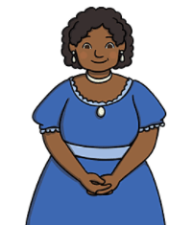 | - Comprehension: I can read and listen to an information text related to Florence nightingale, nursing or Mary Seacole  - I can identify features of an information text  - I can add ‘s’ or ‘es’ to make a noun plural  - I can write an information text related to Florence Nightingale, nursing or Mary Seacole  - Comprehension – I can retrieve information from an information text related to Florence Nightingale, nursing or Mary Seacole  - I can use the suffix -ing  - I can plan an information text about Florence Nightingale, nursing or Mary Seacole  - I can write an information text about Florence Nightingale, nursing or Mary Seacole
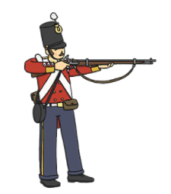  Florence Nightingale & Mary Seacole | Play Scripts | - Comprehension: I can read and listen to a play script related to Florence nightingale & the Crimean War  - I can identify features of a play script and I can role play / act out using a script  - I can use the present and past tense correctly and consistently  - I can write a playscript related to Florence nightingale & the Crimean War  - Comprehension – I can retrieve information from a playscript related to Florence Nightingale, nursing or Mary Seacole  - I can identify and use adverbs  - I can plan a playscript about Florence Nightingale, nursing or Mary Seacole  - I can write an information text about Florence Nightingale, nursing or Mary Seacole
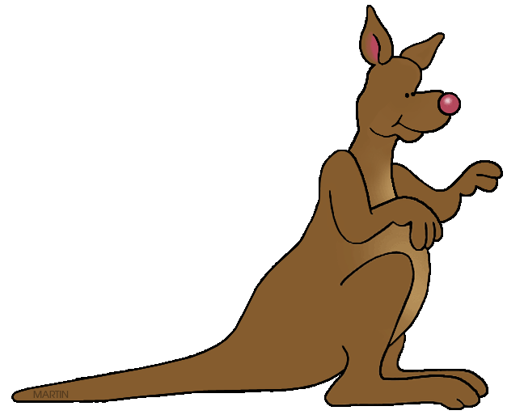  Australia & Oceania | Stories From other cultures | - Comprehension: I can read and listen to a traditional story from Australia such as ‘How the Kangaroo got its Pouch’  - I can identify features of a story and I can retell a story verbally  - I can use co-ordination (e.g. or / and / but) and some subordination (e.g. when / if / that / because) to join clauses.  - I can write an information text related to Florence Nightingale, nursing or Mary Seacole  - Comprehension – I can retrieve information including inference from a traditional story from Australia  - I can draw on and use new vocabulary from my reading and from wider experiences in my writing  - I can plan a story set in Australia  - I can write a story set in Australia
Australia & Oceania | Postcards | - Comprehension: I can read and listen to a postcard from Australia  - I can identify features of a postcard and I can identify how an author describes a setting  - I can use adjectives to add description e.g. the golden sand, blue ocean, tall kangaroo.  - I can write a descriptive postcard from Australia  - Comprehension – I can retrieve information including inference from a postcard from an Australian City  - I can use prepositional phrases of place  - I can research an Australian City and plan a descriptive postcard  - I can write a descriptive postcard from Australia
Australia & Oceania | Animal information Texts  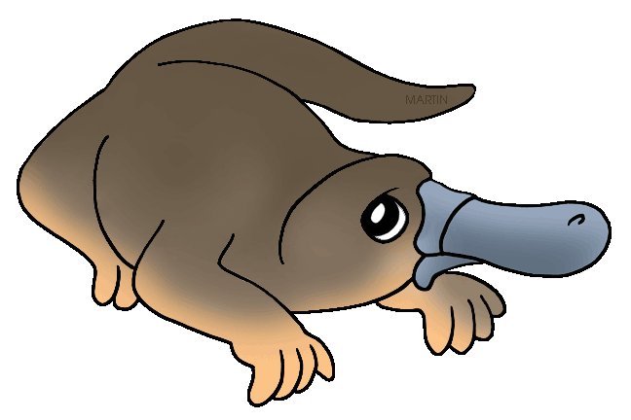 | - Comprehension: I can read and listen to an information text about Australian animals such as a Kangaroo or Koala  - I can identify features of an information text  - I can use –ing, –ed, –er and –est where no change is needed in the spelling of root words  - I can write an information text about an Australian animal  - Comprehension – I can retrieve information from an information text about Australian animals such as a Duckbilled Platypus, Tasmanian wolf or Dugong  - I can add suffixes to spell some words correctly in my writing (e.g. -ment, -ness, -ful, -less, -ly).  - I can plan and research an information text about Australian animals  - I can write an information text about Australian Animals
Weather & Climate | Explanation | - Comprehension: I can read and listen to an explanation text about clouds  - I can identify features of an explanation text  - I can punctuate sentences with a question mark or exclamation mark.  - I can write an explanation text about the weather e.g.: a basic explanation of the water cycle  - Comprehension – I can retrieve information from an explanation text about Thunder storms  - I know how to use paragraphs and I can organise paragraphs around a theme and sequence them logically.  - I can research and plan an explanation text about different storms  - I can write an information text about extreme weather such as hurricanes, tornadoes and lightning storms.
Weather & Climate | Instructions   | - Comprehension: I can read and listen to an instructional text about how to make a paper snowflake  - I can tell a set of instructions from memory and I can identify features of an instruction text  - I can use imperative verbs  - I can write instructions about how to make something related to the weather & climate e.g. a cool refreshing drink or a cup of tea  - Comprehension – I can retrieve information from instructions about how to make a weather station or rain gauge  - I can identify verbs and nouns  - I can research and plan an instructional text about how to make a weather vane.  - I can write instructions about how to make a weather vane
Weather & Climate  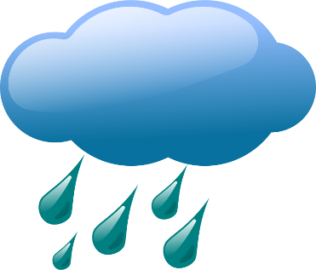 | Weather Poetry | - Comprehension: I can read and listen to a poem about the weather such as ‘splashing in the puddles’  - I can identify features of a poem and I can perform poetry  - I can identify and use alliteration  - I can write poetry about specific weather e.g. snow, rain, sun etc  - Comprehension – I can retrieve information from a poem about weather eg: Weather Poem by Jill Caroll-Hughes  - I can write a simile  - I can write a poem about weather  - I can make simple additions, revisions and proof-reading corrections to improve my writing and I can perform my poetry
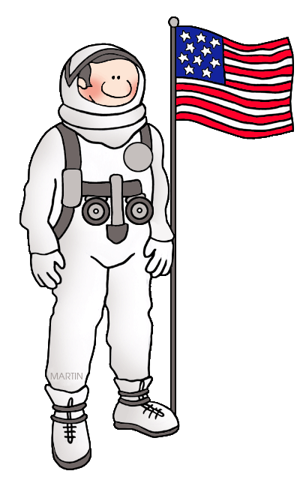  Explorers | News Reports | - Comprehension: I can read and listen to a news report about an explorer such as the first moon landings  - I can identify features of a news report  - I can use the prefix un-  - I can write a news report about Christopher Columbus  - Comprehension – I can retrieve information from a news report about an explorer such as Marco Polo  - I can spell many common exception words.  - I can research and plan a news report about a famous exploration event such as Amundsen & Scott’s race to the South Pole  - I can write a news report about a famous exploration event such as Amundsen & Scott’s race to the South Pole
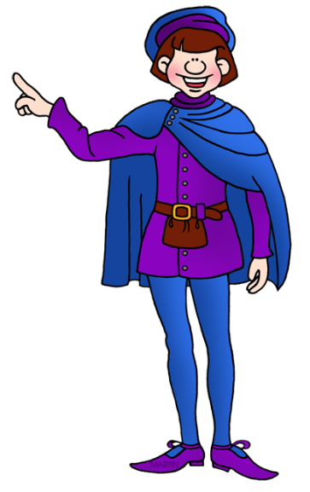  Explorers | Historical Adventure Stories | - Comprehension: I can read and listen to an opening to a historical adventure story  - I can identify features of an adventure story and I can retell a story verbally  - I can punctuate sentences with a question mark or exclamation mark.  - I can write a continuation of an adventure story  - Comprehension – I can retrieve information including inference from an adventure story  - I can identify and use sentences with different forms in my writing (statements, questions, exclamations and commands)  - I can plan an adventure story with a beginning, middle and end  - I can write an adventure story with a beginning, middle and end
Explorers | Diaries & Letters | - Comprehension: I can read and listen to a letter from an explorer  - I can identify features of a letter and I can retell a letter verbally  - I can spell days of the week and I know these need a capital letter.  - I can write a letter from the point of view of an explorer  - Comprehension – I can retrieve information including inference from a letter or diary from an explorer  - I can use capital letters for names, places, days of the week and the personal pronoun ‘I’  - I can research and plan a letter or diary from the point of view of an explorer  - I can write a letter or diary from the point of view of an explorer
Our Local Area: Yorkshire | Stories with familiar settings | - Comprehension: I can read and listen to a story by a local author / setting such as: The little village School by Gervase Phinn  - I can identify how a vivid setting is created by an author  - I can use expanded noun phrases to describe and specify, e.g. the blue butterfly, plain flour  - I can write a continuation of an adventure story  - Comprehension – I can retrieve information including inference from a story by a local author / setting such as Escape from Nettle Farm by Justin Davis or The little village School by Gervase Phinn  - I can spell some words with contracted forms.  - I can plan a story with a familiar setting that has a beginning, middle and end  - I can write a story with a familiar setting that has a beginning, middle and end
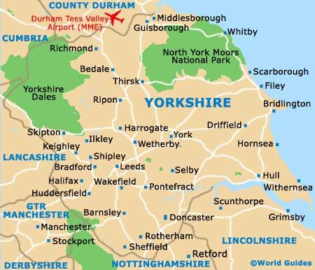  Our Local Area: Yorkshire | Information Texts | - Comprehension: I can read and listen to an information text about Yorkshire  - I can identify features of an information text  - I can join words and join clauses using "and"  - I can write an information text about Yorkshire  - Comprehension – I can retrieve information from an information text about Newbald  - I can use co-ordination (e.g. or / and / but) and some subordination (e.g. when / if / that / because) to join clauses.  - I can plan and research an information text about Newbald  - I can write an information text about Newbald
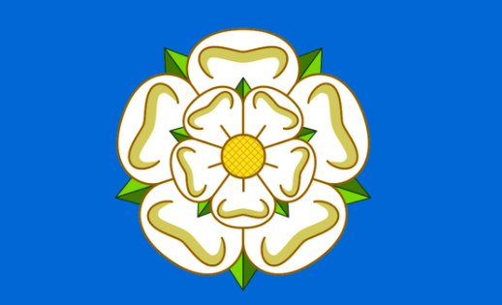  Our Local Area: Yorkshire | Poetry (Language Play) | - Comprehension: I can read and listen to poems by a local author such as a poem included in the book There’s an Alien in the Classroom by Gervase Phinn  - I can identify features of a poem and I can roleplay and retell a poem verbally  - I can identify and use onomatopoeia  - I can write poetry about the local area or school  - Comprehension – I can retrieve information from poems by a local author such as a poem included in the book There’s an Alien in the Classroom by Gervase Phinn  - I can use personification in my poetry  - I can write a poem about the local area or school  - I can make simple additions, revisions and proof-reading corrections to improve my writing and I can perform my poetry
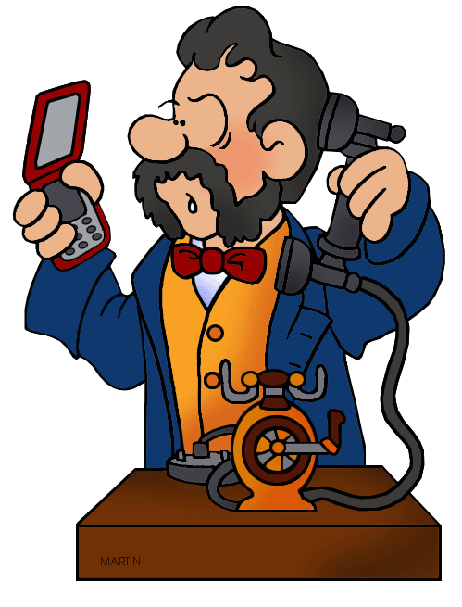  Inventors & Inventions | Persuasive Writing | - Comprehension: I can read and listen to a persuasive text e.g. Grass Flip Flops  - I can identify features of a persuasive text and I can role play verbally radio advertisements persuading people to buy new inventions / products  - I can use coordinating conjunctions  - I can write a persuasive text to encourage people to buy their new invention  - Comprehension – I can retrieve information from a persuasive text eg: a text that give reasons why sliced bread is the best invention of all time.  - I can spell and create compound words  - I can plan and research a persuasive text about an invention persuading people to vote for a chosen invention as the best invention of all time  - I can write a persuasive text about an invention persuading people to vote for a chosen invention as the best invention of all time
Inventors & Inventions | Biographies | - Comprehension: I can read and listen to a biography about Thomas Edison  - I can identify features of a biography text  - I can use present and past tense mostly correctly and consistently.  - I can write a biography about William Caxton  - Comprehension – I can retrieve information from a biography about Thomas Edison  - I can demarcate sentences with capital letters and full stops, and use question marks correctly when required.  - I can research Tim Berners Lee and plan a biography about him  - I can write a biography about Tim Berners Lee
Inventors & Inventions | Imaginative Fiction Writing   | - Comprehension: I can read and listen to part of an imaginative story about an invention eg Wallace and Gromit: The Wrong Trousers (Part 1)  - I can identify features of an imaginative story and I can retell a story verbally  - I can spell homophones e.g. bear & bear, blue & blew etc  - I can plan and write an opening to an imaginative story about an invention  - Comprehension – I can retrieve information including inference from an imaginative story about an invention eg Wallace and Gromit: The Wrong Trousers (Part 2)  - I can identify verbs, nouns, adverbs & adjectives and use them in my sentences  - I can plan and write a middle to an imaginative story about an invention  - I can plan and write an ending to an imaginative story about an invention
Transport through time | Labels, lists and captions  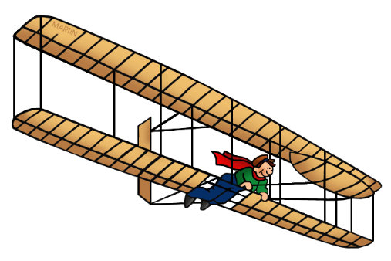 | - Comprehension: I can look at, read and listen to labelled pictures and illustrations of transport through time  - Comprehension: I can look at, read and listen to labelled pictures and illustrations of transport through time  - I can use vocabulary provided by the teacher in my writing  - I can label pictures and diagrams of modes of transport through time  - Comprehension – I can retrieve information from an explanation text that includes labels, bullet points, lists and captions  - I can spell singular nouns and plural nouns using the suffixes –s or –es  - I can plan and research an explanation text about a mode of transport through time  - I can write labels, lists and captions about a mode of transport through time
Transport through time | Biographies  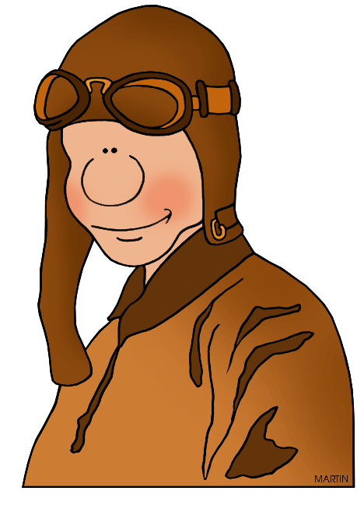 | - Comprehension: I can read and listen to a biography about the Wright Brothers  - I can identify features of a biography text  - I can use full stops and capital letters to demark sentences accurately  - I can write a biography about George Stephenson  - Comprehension – I can retrieve information from a biography about Bessie Coleman  - I can use present and past tense mostly correctly and consistently.  - I can research Amy Johnson and plan a biography about her  - I can write a biography about Amy Johnson
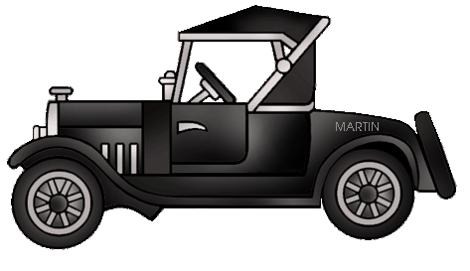  Transport through time | Transport Stories | - Comprehension: I can read and listen to a story that involves transportation  - I can identify how a character is created by an author  - I can use expanded noun phrases to describe and specify, e.g. the fast train, the blue helicopter the useful bus  - I can write an opening to a story about transportation  - Comprehension – I can retrieve information including inference from a story that involves transportation  - I can use co-ordination (e.g. or / and / but) and some subordination (e.g. when / if / that / because) to join clauses.  - I can plan and write a middle of a story about transport  - I can plan and write an end to a story about transport
Polar Regions | Explanation Texts | - Comprehension: I can read and listen to an explanation text about a polar animal e.g.: How are polar bears adapted to their setting?  - I can identify features of an explanation text  - I can identify questions and use question marks accurately in my writing  - I can write an explanation text about how an arctic fox or walrus is adapted to its habitat  - Comprehension: I can read and listen to an explanation text about a polar animal e.g.: How are penguins adapted to their setting?  - I can use commas for listing (including listing adjectives)  - I can plan and research an explanation text (including preparing labelled pictures) about how a polar animal is adapted to its habitat e.g.: ‘How are seals protected against the cold?’  - I can write an explanation text about how a polar animal is adapted to its habitat e.g.: ‘How are seals protected against the cold?’
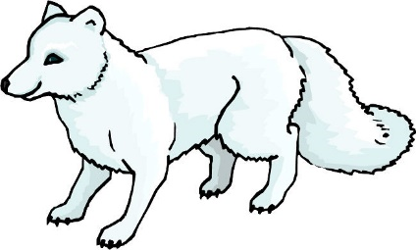  Polar Regions | Adventure Stories set in the Polar Regions | - Comprehension: I can read and listen to an opening of a story about the Arctic  - I can begin to use speech marks for words being said  - I can use expanded noun phrases to describe and specify, e.g. the glistening ice, the desolate landscape, the fierce polar bear  - I can write a continuation of a story set in the Arctic  - Comprehension – I can retrieve information including inference from a story that is set in the Arctic  - I can use synonyms to improve my writing e.g. whispered instead of said, colossal instead of big etc  - I can plan a continuation of a story set in the Arctic  - I can write a continuation of a story set in the Arctic
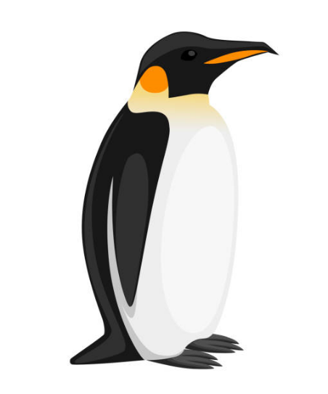  Polar Regions | Poetry | - Comprehension: I can read and listen to a poem about a polar animal e.g.: I am a polar bear  - I can identify features of a poem including rhythm and rhyme and I can perform / and retell a poem verbally  - I can identify rhyming words to use in my poetry  - I can write poetry about a polar animal  - Comprehension – I can retrieve information from a poem about the Arctic / Antarctic e.g.: Polar bear, Arctic hare: Poems of the Frozen North by Eileen Spinelli  - I can identify and use similes in my writing  - I can write an acrostic poem about the polar regions  - I can write a shape poem about a polar animal
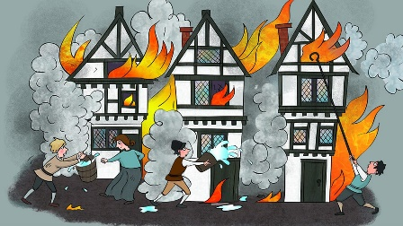  Great Fire of London | Information Texts | - Comprehension: I can read and listen to an information text about the Great Fire of London  - I can identify features of an information text  - I can identify letters that are vowels and letters that are consonants  - I can write an information text about the Great Fire of London  - Comprehension – I can retrieve information from an information text about the Great Fire of London  - I can spell the Year 1 exception words.  - I can plan and research an information text about the Great Fire of London  - I can write an information text about the Great Fire of London
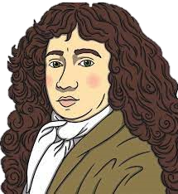  Great Fire of London | Diaries & Recounts | - Comprehension: read and listen to recounts about the great fire of London including looking at Samuel Pepys’ diary  - I can tell a recount from memory & I can deepen my understanding of a recount through roleplay  - I can identify use verb tenses with increasing accuracy in speaking and writing, e.g. catch/caught, see/saw, go/went etc.  - I can write a diary about real events recording these simply and clearly  - Comprehension – I can retrieve information from a diary & identify features of a diary  - I can use capital letters for names, places and days of the week and the personal pronoun “I”. with greater accuracy in my writing.  - I can plan a diary about the great fire of London  - I can write a diary about the great fire of London
Great Fire of London | Play Scripts | - Comprehension: I can read and listen to a play script related to the Great Fire of London & The Black Plague  - I can identify features of a play script and I can role play / act out using a script  - I can spell, identify and use adverbs using the suffix ‘-ly’  - I can write a play script related to the Great Fire of London  - Comprehension – I can retrieve information from a playscript related to the Great Fire of London & The Black Plague  - I can change adjectives into adverbs  - I can plan a playscript about the Great Fire of London & The Black Plague  - I can write a playscript about the Great Fire of London & The Black Plague
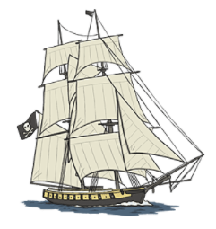  Pirates & the Oceans | Information Texts | - Comprehension: I can read and listen to an information text about Pirates eg: Pesky Pirates  - I can identify features of an information text  - I can use conjunctions to create subordination (e.g. when / if / that / because) to join clauses  - I ca n write an information text about famous Pirates eg: Blackbeard, Grace O’Malley etc  - Comprehension – I can retrieve information from an information text about Pirate Ships  - I can add suffixes to spell most words correctly (e.g. –ment, –ness, –ful, –less, –ly).  - I can plan and research an information text about Pirates  - I can write an information text about Pirates
Pirates & the Oceans | Poems to perform & Sea-Shanties | - Comprehension: I can read and listen to a poem about pirates including sea-shanties eg: Pirate Crew, I’m a Pirate, We’re Off on an Adventure & Pirate Ship Counting Song  - I can identify features of a poem including rhythm and rhyme and I can perform / and retell a poem verbally  - I can identify rhyming words to use in my poetry  - I can write poetry about pirates  - Comprehension – I can retrieve information from a poem about the Ocean eg: The Ocean Home  - I can use alliteration and onomatopoeia to create lines of poetry  - I can write a poem about the ocean  - I can make simple additions, revisions and proof-reading corrections to improve my writing and I can perform my poetry
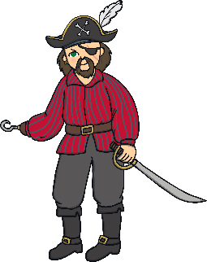  Pirates & the Oceans | Persuasion | - Comprehension: I can read and listen to a persuasive text e.g. a text persuading people to ‘join the pirate crew or a ‘Wanted’ poster for a pirate’  - I can identify features of a persuasive text and I can role play persuading people to join their pirate crew  - I can use the prefix un–  - I can write a persuasive text to encourage people to join their pirate crew  - Comprehension – I can retrieve information from a persuasive text e.g.: a text persuading people not to throw litter in the ocean  - I can use and correctly punctuate sentences with different forms in my writing (statements, questions, exclamations and commands).  - I can plan and research a persuasive text about the ocean  - I can write a persuasive text about the ocean
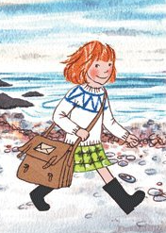  An Island Home | Katie Morag Stories | - Comprehension: I can read and listen to a Katy Morag Story e.g.: Katie Morag Delivers the Mail by Mari Hedderwick  - I can identify features of a story. I can identify how the author has created settings & character and I can verbally retell / role play a story  - I can spell and use a variety of pronouns accurately  - I can write a story set in Scotland  - Comprehension – I can retrieve information from a Katy Morag Story e.g.: Katie Morag Delivers the Mail by Mari Hedderwick  - I can plan a contin uation of a story set in Scotland  - I can write a continuation of a story set in Scotland that has a beginning, middle & an end.  - I can re-read what I have written to check that it makes sense and I can make improvements to my writing
An Island Home | Information Texts  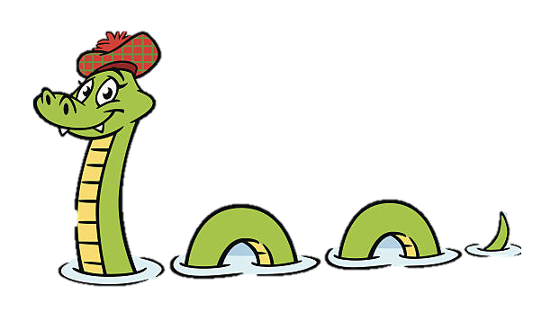 | - Comprehension: I can read and listen to an information text about Scotland e.g.: the Cairngorm National Park  - I can identify features of an information text  - I can use commas to separate items in a list  - I can write an information text about the Cairngorm National Park  - Comprehension – I can retrieve information from an information text about a Scottish City e.g.: Edinburgh  - I can spell many common exception words.  - I can plan and research an information text about a Scottish City  - I can write an information text about a Scottish City
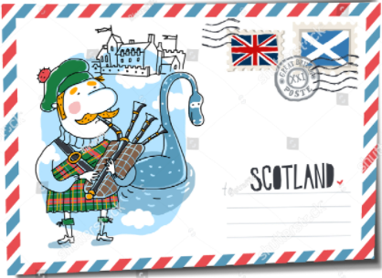  An Island Home | Postcards | - Comprehension: I can read and listen to a postcard from Scotland  - I can identify features of a postcard and I can identify how an author describes a setting  - I can use adjectives to add description e.g. the gnarled tree, the rickety boat  - I can write a descriptive postcard from Scotland  - Comprehension – I can retrieve information including inference from a postcard from Scotland  - I can use an apostrophe to spell some words with contracted forms.  - I can research a place / island in Scotland and plan a descriptive postcard  - I can write a descriptive postcard from Scotland
Kings & Queens | Non-Chronological Reports | - Comprehension: I can read and listen to a non-chronological report about a King or Queen of England e.g. William I (William the Conqueror)  - I can identify features of a non-chronological report  - I can create adjectives using the suffixes -er and –est  - I can write a non-chronological report about a King or Queen of England e.g. Elizabeth I  - Comprehension – I can retrieve information from a non-chronological report about a Kings or Queen of England e.g. Queen Victoria  - I can use present and past tense mostly correctly and consistently in my writing including using past and progressive tenses  - I can plan and research an information text about a Queen Elizabeth II  - I can write an information text about Queen Elizabeth II
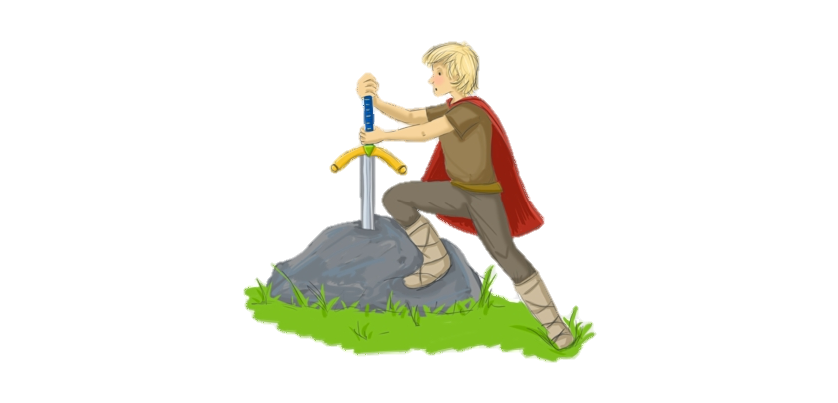  Kings & Queens | Stories | - Comprehension: I can read and listen to a Story about a king (either real or mythical) e.g.: The Legend of King Arthur and the Sword in the Stone  - I can identify features of a story. I can identify how the author has created settings & character and I can verbally retell / role play a story  - I can use a variety of punctuation taught correctly, including: capital letters, full stops, question marks, exclamation marks commas to separate items in a list  - I can write a story set in Scotland  - Comprehension – I can retrieve information from a Katy Morag Story e.g.: The Legend of King Arthur and the Sword in the Stone  - I can use apostrophes to mark where letters are missing in spelling and to mark singular possession in nouns [for example, the girl’s name].  - I can plan a sequel to a story about a mythical King  - I can write a sequel to a story about a mythical King that has a beginning, middle & an end.
Kings & Queens | 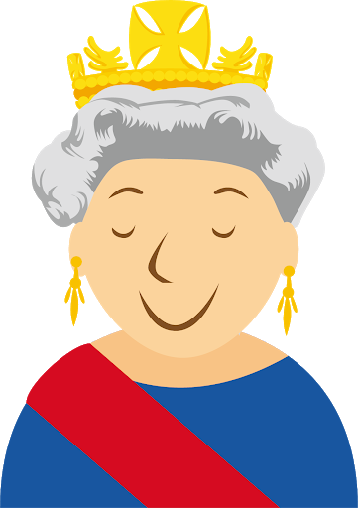  News Reports | - Comprehension: I can read and listen to a news report about a King or Queen of England Eg: Defeat of the Spanish Armada by Elizabeth I or End of the English Civil War & Beheading of King Charles I  - I can identify features of a news report including headlines  - I can add suffixes to spell some words correctly in my writing (e.g. -ment, -ness, -ful, -less, -ly).  - I can write a news report about King or Queen of England E.g.: Lady Jane Grey – Queen for 9 days  - Comprehension – I can retrieve information from a news report about a King or Queen of England eg: The adoption of the Magna Carta by King John  - I can identify nouns, adjectives, verbs and adverbs  - I can research and plan a news report about the royal family  - I can write a news report about the royal family e.g.: A royal wedding, The Queen’s coronation etc

